

**PROJECT REPORT**

On

**E-COMMERCE WEBSITE - SENG SHOP**

submitted to

**LOVELY PROFESSIONAL UNIVERSITY**

in partial fulfillment of the requirements of

the award of the degree/diploma of

“BACHELOR OF COMPUTER APPLICATIONS “

Submitted By

ANMOLPREET SINGH

Registration No: 22106590166

(2024)

**Lovely Professional University, Phagwara**

**Lovely Faculty of Distance Education**

**DECLARATION**

(By the Student)

This to certify that the project report titled “**SENG SHOP: an -commerce website “**submitted by “**Anmolpreet Singh** “, “**Registration No: 22106590166** “In partial fulfillment for the award of **“Bachelor of Computer** **Applications**” from **Lovely Professional University, Phagwara** is a record of original work done by me. This project has not been submitted to any other University or Institution for the award of any Degree/Diploma/certificate.

Signature of the student

Place: **Lovely Professional University**

Date: 19-12-2024

TABLE OF CONTENT

INTRODUCTION 1

OBJECTIVES 2

THE MAIN FEATURES OF PROJECT 2

THE RUNNING PROCESS OF PROJECT 3

Run using VS Code and Live Server Extension 4

Run using XAMPP 6

FEATURES OF PROJECT 16

1. User Friendly and Interactive Interface: 16

2. Search Feature: 28

3. Product Cart Preview 32

4. Shopping Cart 35

5. Shipping Form 41

6. Progress Section 47

7. Terms And Conditions 49

8. Invoice Pdf Generator 52

9. Responsiveness 56

Tailwind CSS 60

GIT HUB 64

Future Updates and Possibilities 66

Links And References 67

# INTRODUCTION

This frontend web project is developed using HTML, CSS, JavaScript, Tailwind CSS, jsPDF and GitHub. Talking about this project, it is an e-commerce website that includes variety electronic products for shopping. This project allows users / customers to easily find, explore and purchase products.

For building this webpage: HTM, CSS and JAVASCRIPT were used



The PDF generation functionality in this project is implemented using the jsPDF open-source library.



Additionally for tracking and optimization of code Git Hub was used and for simplifying styling Tailwind CSS was used.



# OBJECTIVES

This project is a simple e-commerce website where users can:

1. Explore and search a variety of electronic products.

2. Select their preferred items, add them to the cart.

3. Manage their purchases easily.

4. Place an order by providing a shipping address and choosing a payment option.

5. At the end after placed the order an invoice in PDF format will be generated, detailing the ordered items and the customer's entered information.

# THE MAIN FEATURES OF PROJECT

1. User-Friendly Interface
2. Search Feature
3. Product Cart Preview
4. Shopping Cart
5. Shipping Form
6. Terms And Conditions
7. Invoice Pdf Generator
8. Responsiveness (across both desktop and mobile devices).

# THE RUNNING PROCESS OF PROJECT

This project is designed to run on modern web browsers. The following browsers are recommended for the best experience:

1. Google Chrome
2. Microsoft Edge
3. Mozilla Firefox



Chrome



Microsoft Edge



Mozilla

There are two methods to run this project:

1. Using Visual Studio Code and Live Server Extension
2. Using XAMPP



XAMPP

VS Code

## Run using VS Code and Live Server Extension

About Visual Studio Code:

Visual Studio Code (VS Code) is a free code editor by Microsoft. It supports extensions like Live Server, which allows developers to work on their projects in real-time directly in the browser.

1. Download Visual Studio Code (VS Code) from visualstudio.com <https://code.visualstudio.com/download> and install it.

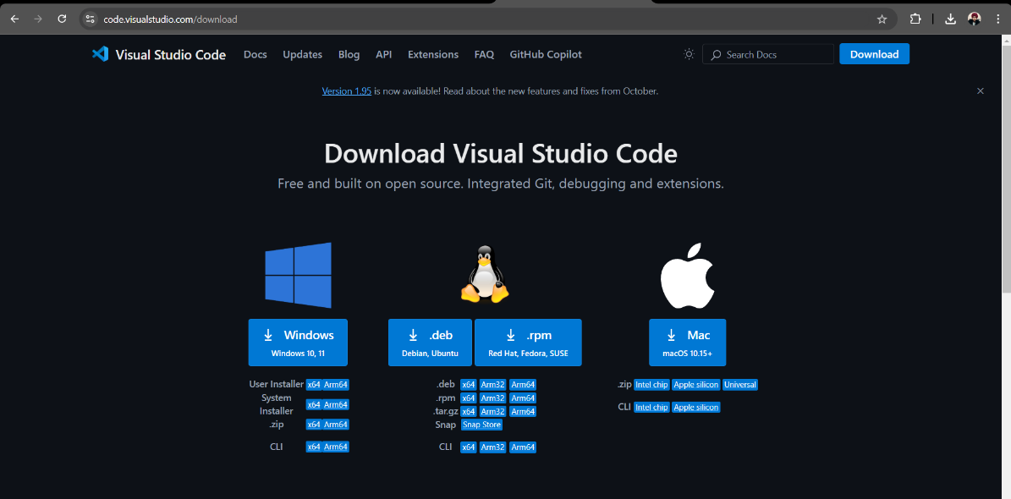

2. Open the Extension Marketplace from side menu install the Live Server extension in VS Code.

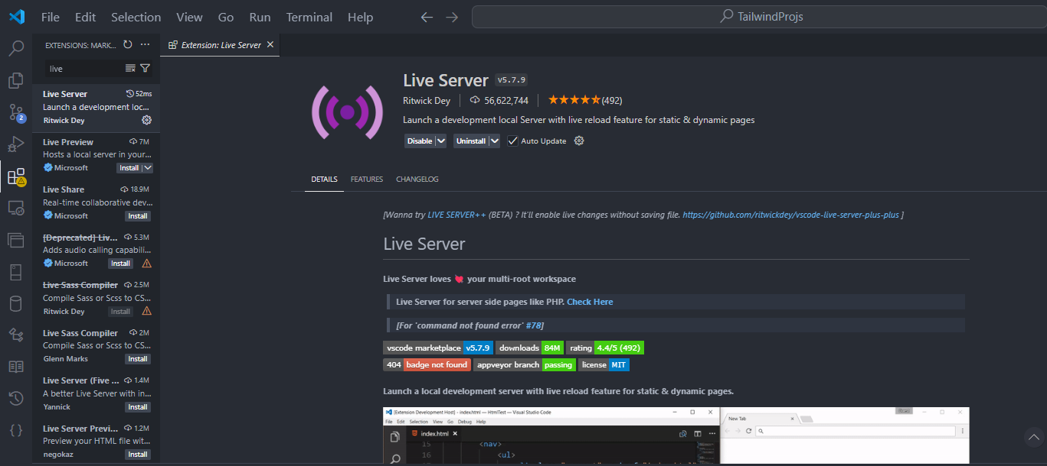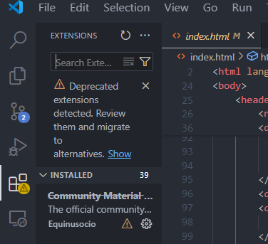

1. Navigate the project files Open the TailwindProjs\index.html in VS Code.

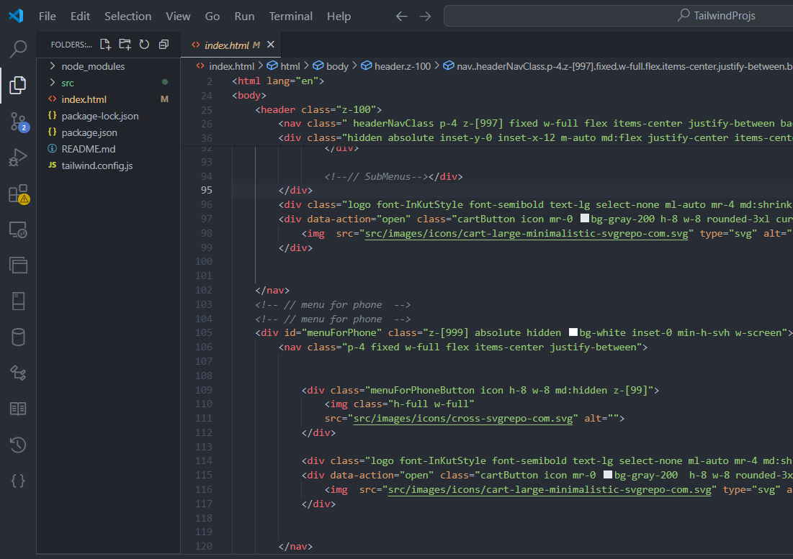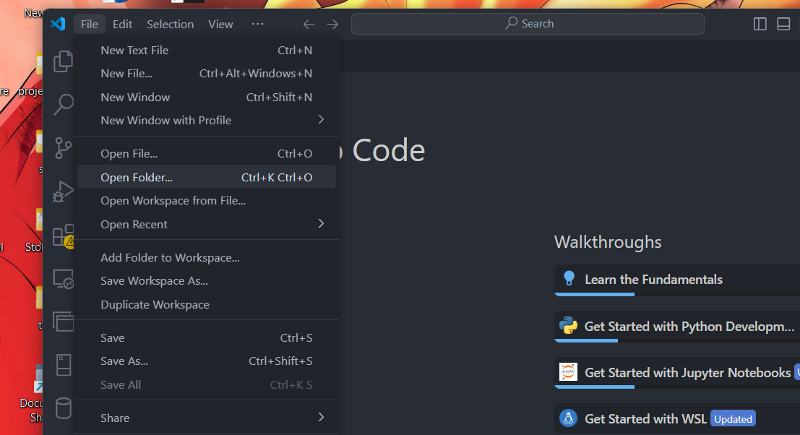

1. Right-click on the code editor and select the Open with Live Server option.

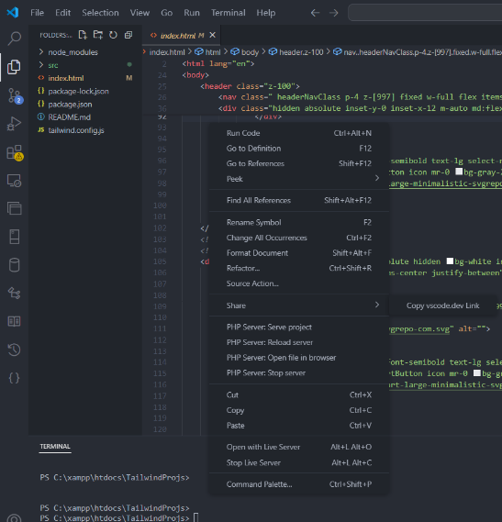

5. The project will open in your default browser.

## Run using XAMPP

About XAMPP :

It is a free, open-source software package that provides a local server environment for web applications. It includes Apache, MySQL, PHP, and Perl, making it easy to set up a fully functional server on your computer.

1. Start the Apache and MySQL servers from the XAMPP Control Panel.

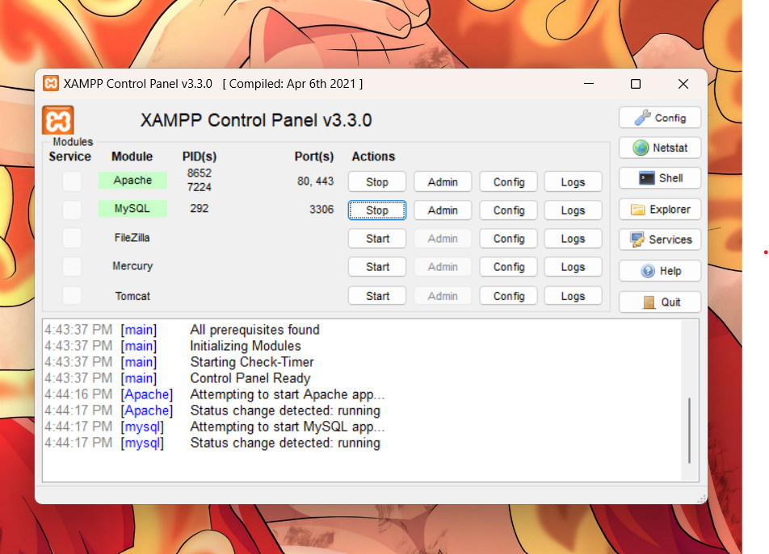

1. Move the project folder to the htdocs directory in the XAMPP installation folder. Example: C:\xampp\htdocs\TailwindProjs

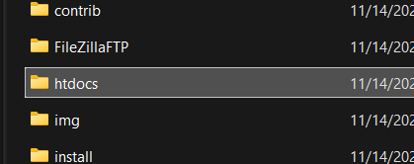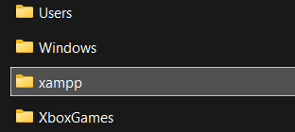

1. Open your browser (e.g., Chrome) and navigate to http://localhost/index.html in the URL bar.
2. The project will open in your Chrome browser.

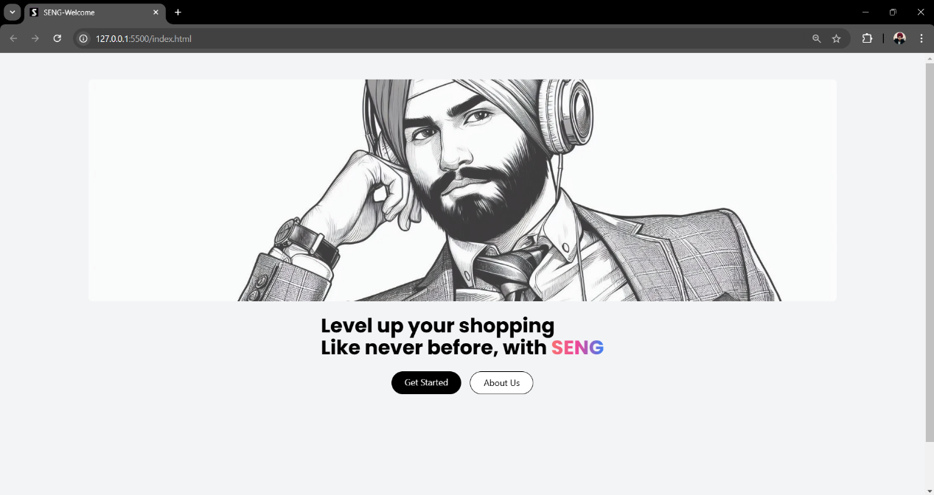After completing all these steps, you will see the project running on your screen.

This is the first page of our website, displayed in the Chrome browser. It serves a welcome page, greeting the user and providing two options: 'Get Started' to visit the official homepage of the website and 'About Us' to learn more about this platform.

Let's dive into the main objectives and features of project by placing an order from this website step by step as follows:

1. By clicking on 'Get Started' we will be directed to our homepage.

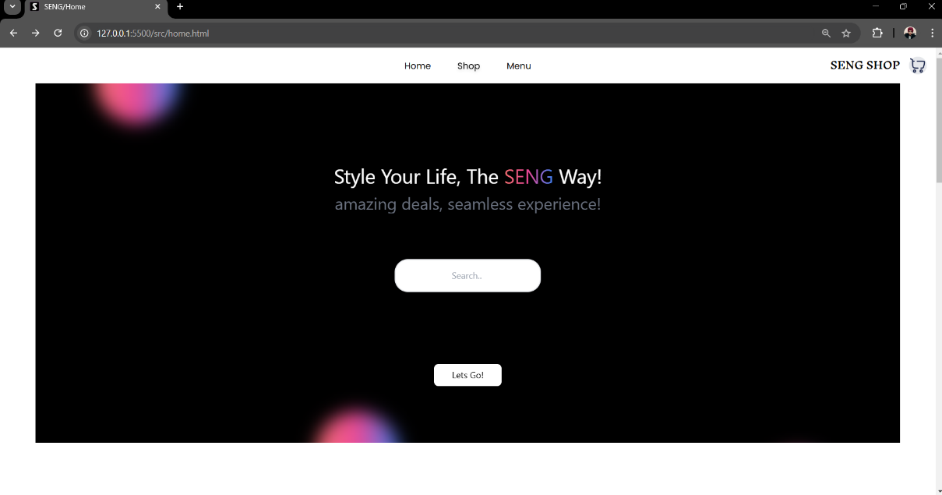

This is our homepage, where users can explore various tech products, make purchases, and take a tour of our website.

1. The user needs to explore and find any item they wish to purchase.
2. Then, click on the 'Order' button to add the desired item to the shopping cart.

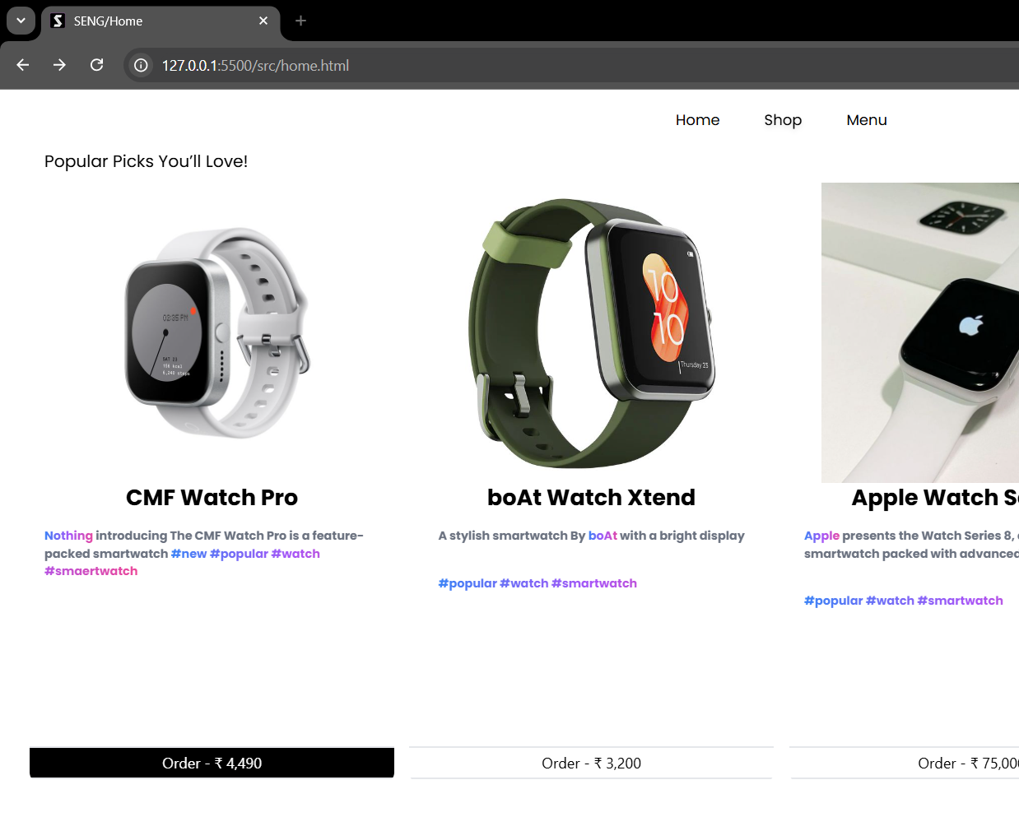

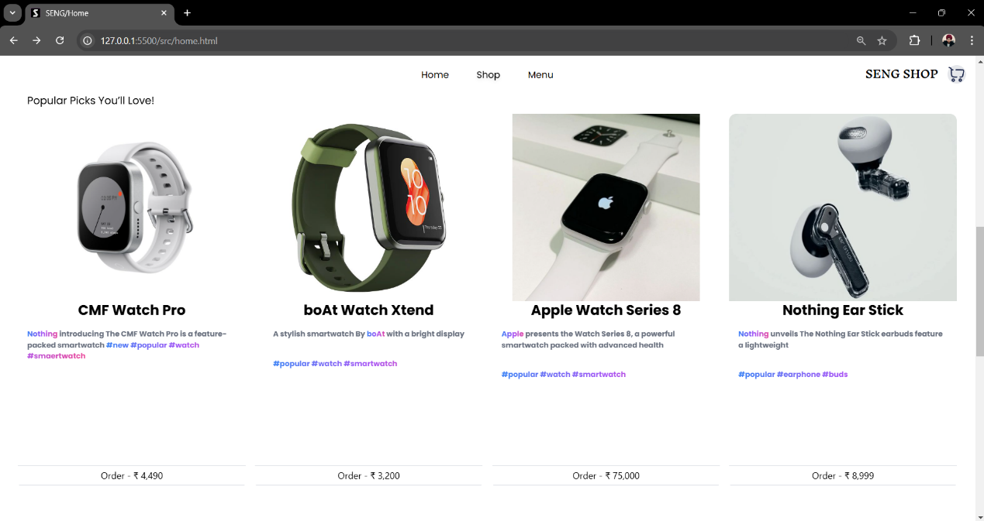

1. Click on the shopping cart icon in the top-right section of the website's menu bar to preview the added items

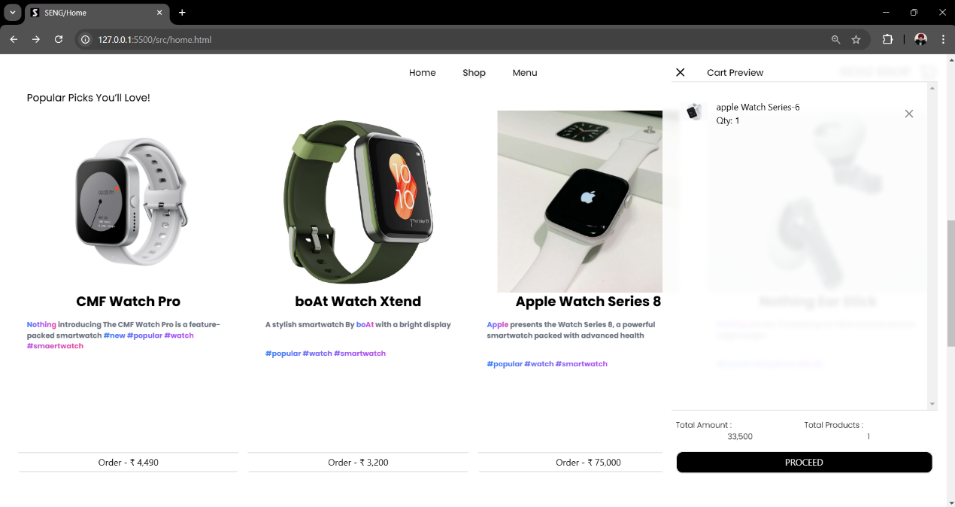

This is the cart preview section, where users can see all the items they have selected, the quantity of each item in the shopping cart, and the total amount of the cart.

1. Click on the 'Proceed' button located at the bottom of the cart preview section to manage and edit the items in the shopping cart on the ‘Order Summary’ page.

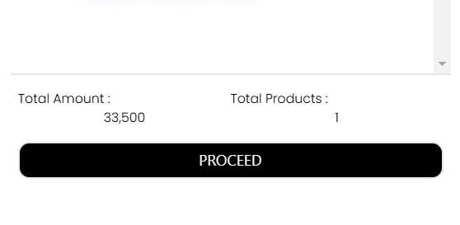

This is the shopping cart section, where users can view a summary of their cart items, all applicable taxes and charges. They can also manage their orders by adjusting the quantity of items or removing items from the shopping cart.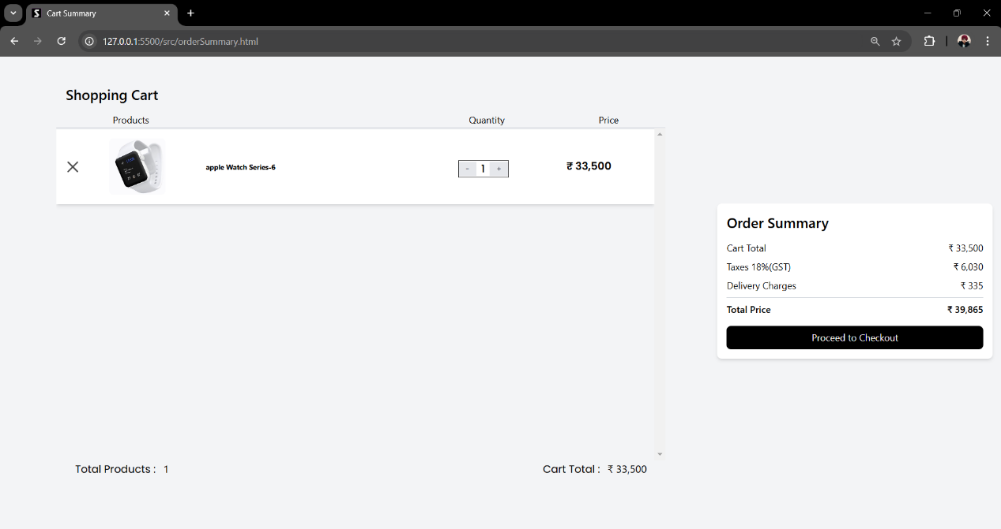

1. After that, the user needs to click on the 'Proceed to Checkout' button located in the bill section on the right side of the cart page to enter the shipping address for their order.

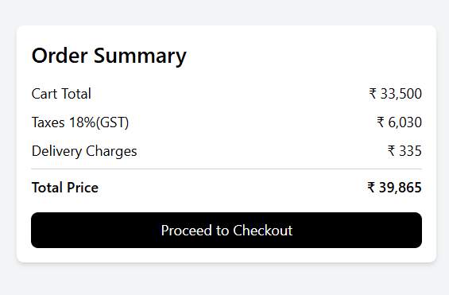

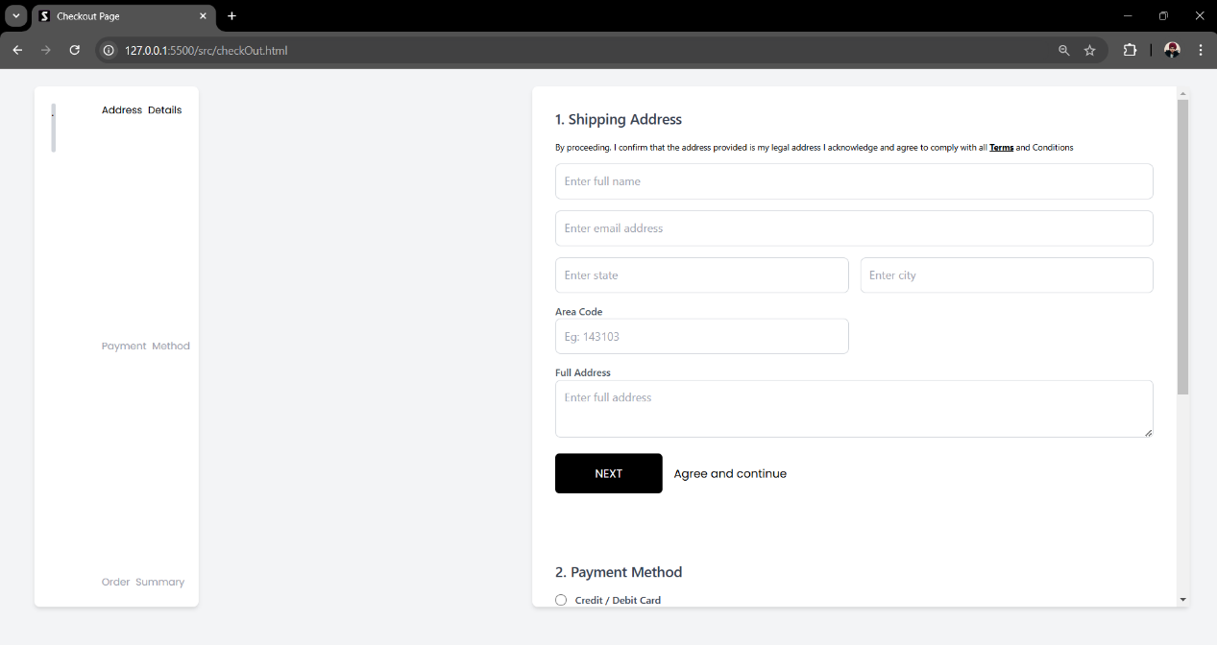

This is the checkout page, where the user needs to enter their shipping details, credentials, and payment method. Finally, before completing the last step of the ordering process

1. The user must carefully fill out all the input fields in the shipping form, including full name, email address, state, city, area code, and full address. Then, click the 'Next' button to continue shopping process.

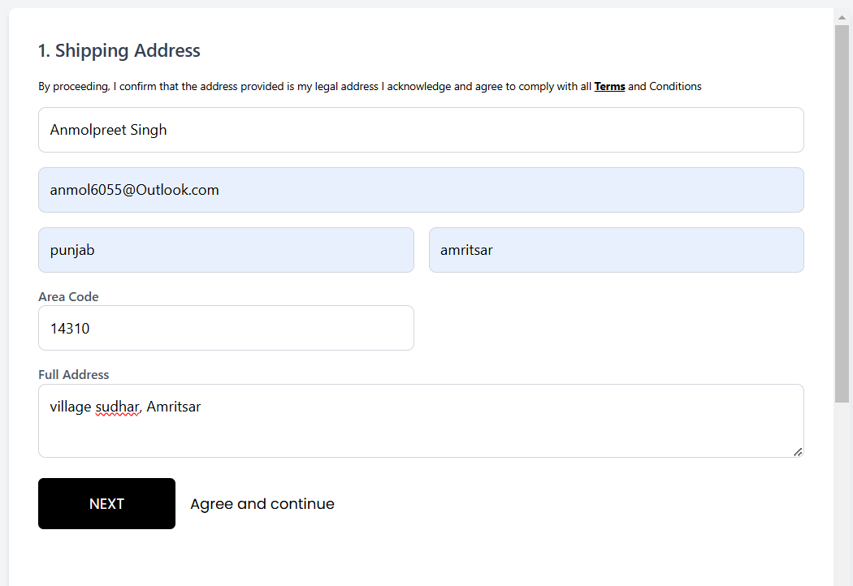

1. Now, the user must select a payment method before proceeding to the final step

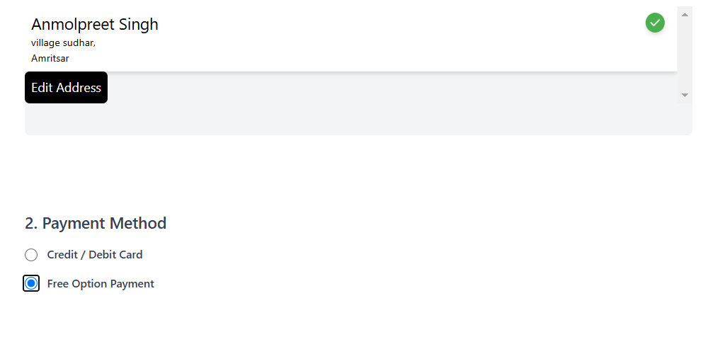

1. 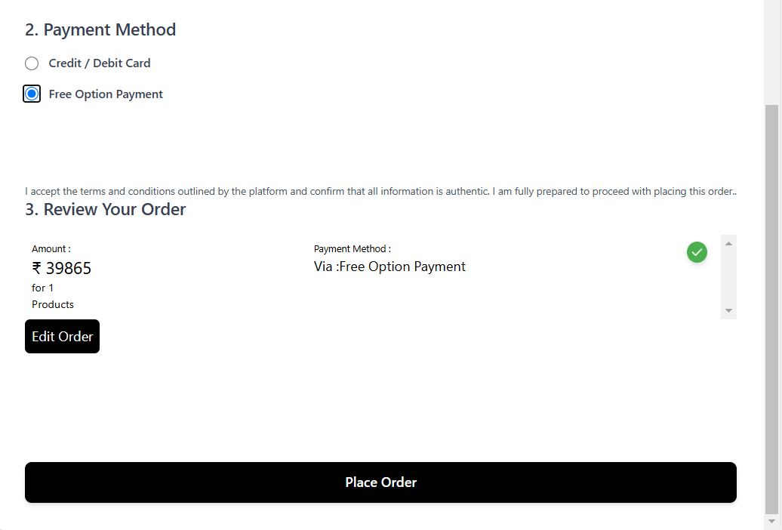 This is the final step of placing an order. Here, the user must review all their details and order items to confirm the order. Once everything is verified, the user should click the 'Place Order' button at the bottom of the checkout page to finalize the order
2. Now, the user must wait until the PDF invoice for their order is generated. Once the invoice is ready, it will automatically download to the user's device

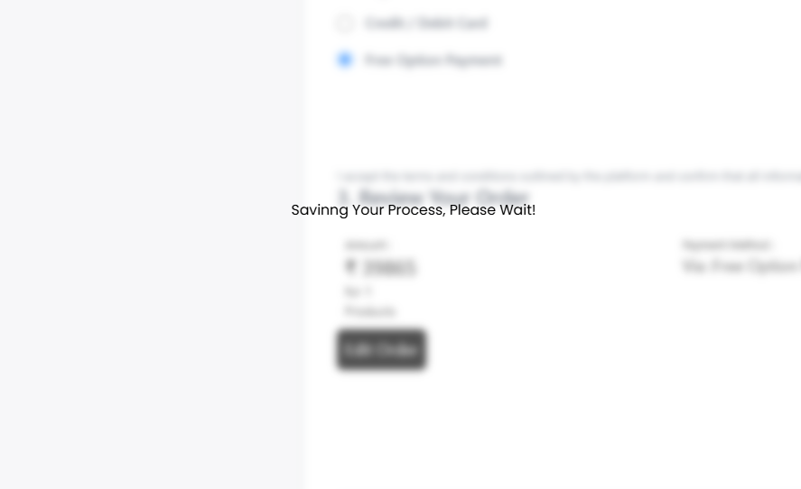

1. Once the PDF is downloaded, click 'OK' to finish the shopping process.

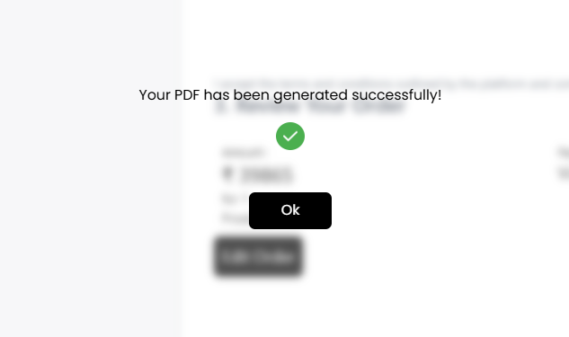

The user can save and view their invoice PDF from the download section of their browser.

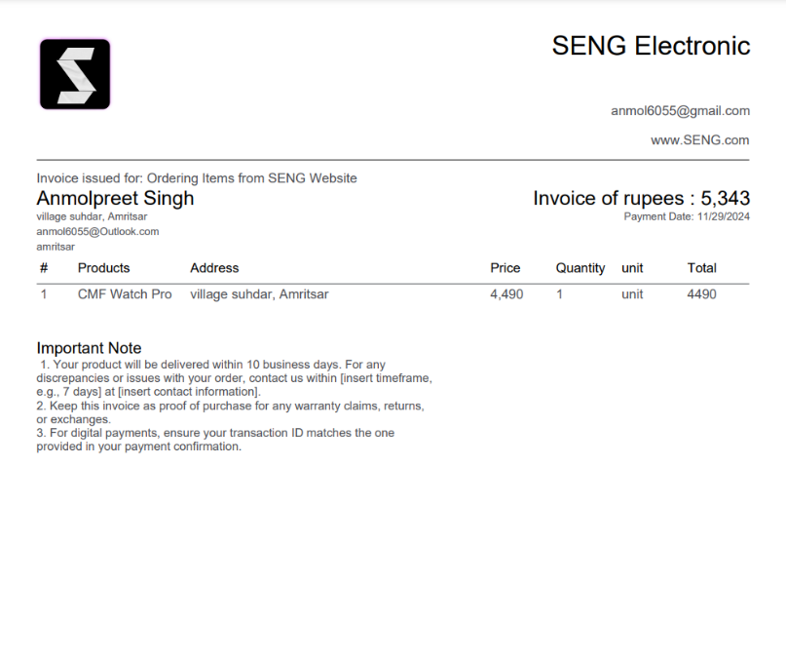

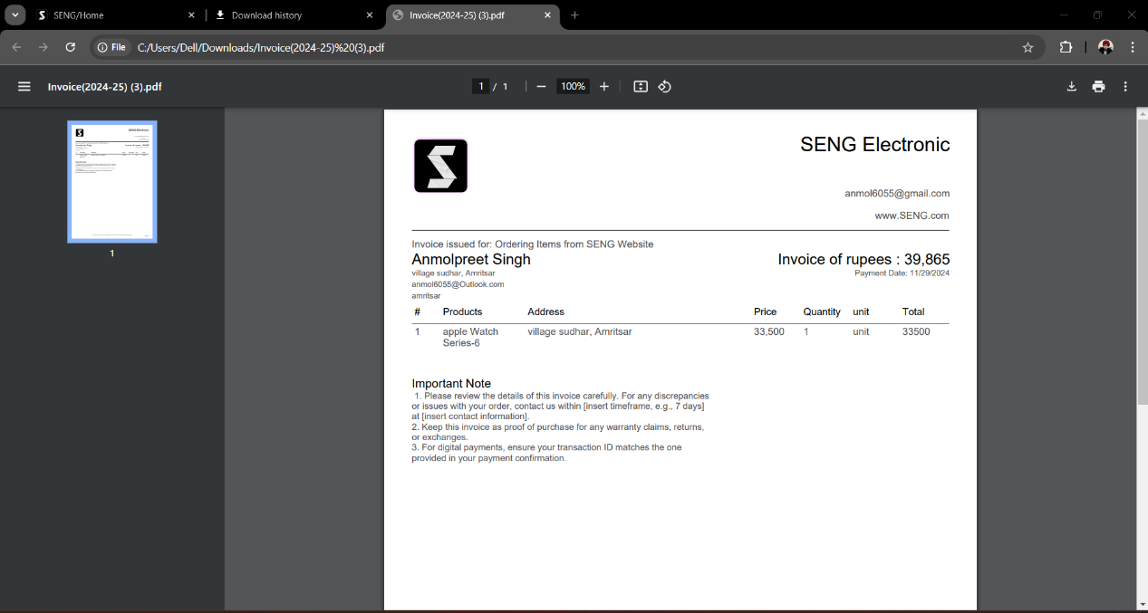

An invoice is provided to the user after successfully placing an order. The invoice includes a receipt of the user's purchases, detailing the items, their amounts, and the user's address. It also contains other important information, such as delivery timing and customer support contact details.

# FEATURES OF PROJECT

## User Friendly and Interactive Interface:

* 1. Easy to use menu with a simple, sleek, modern layout.

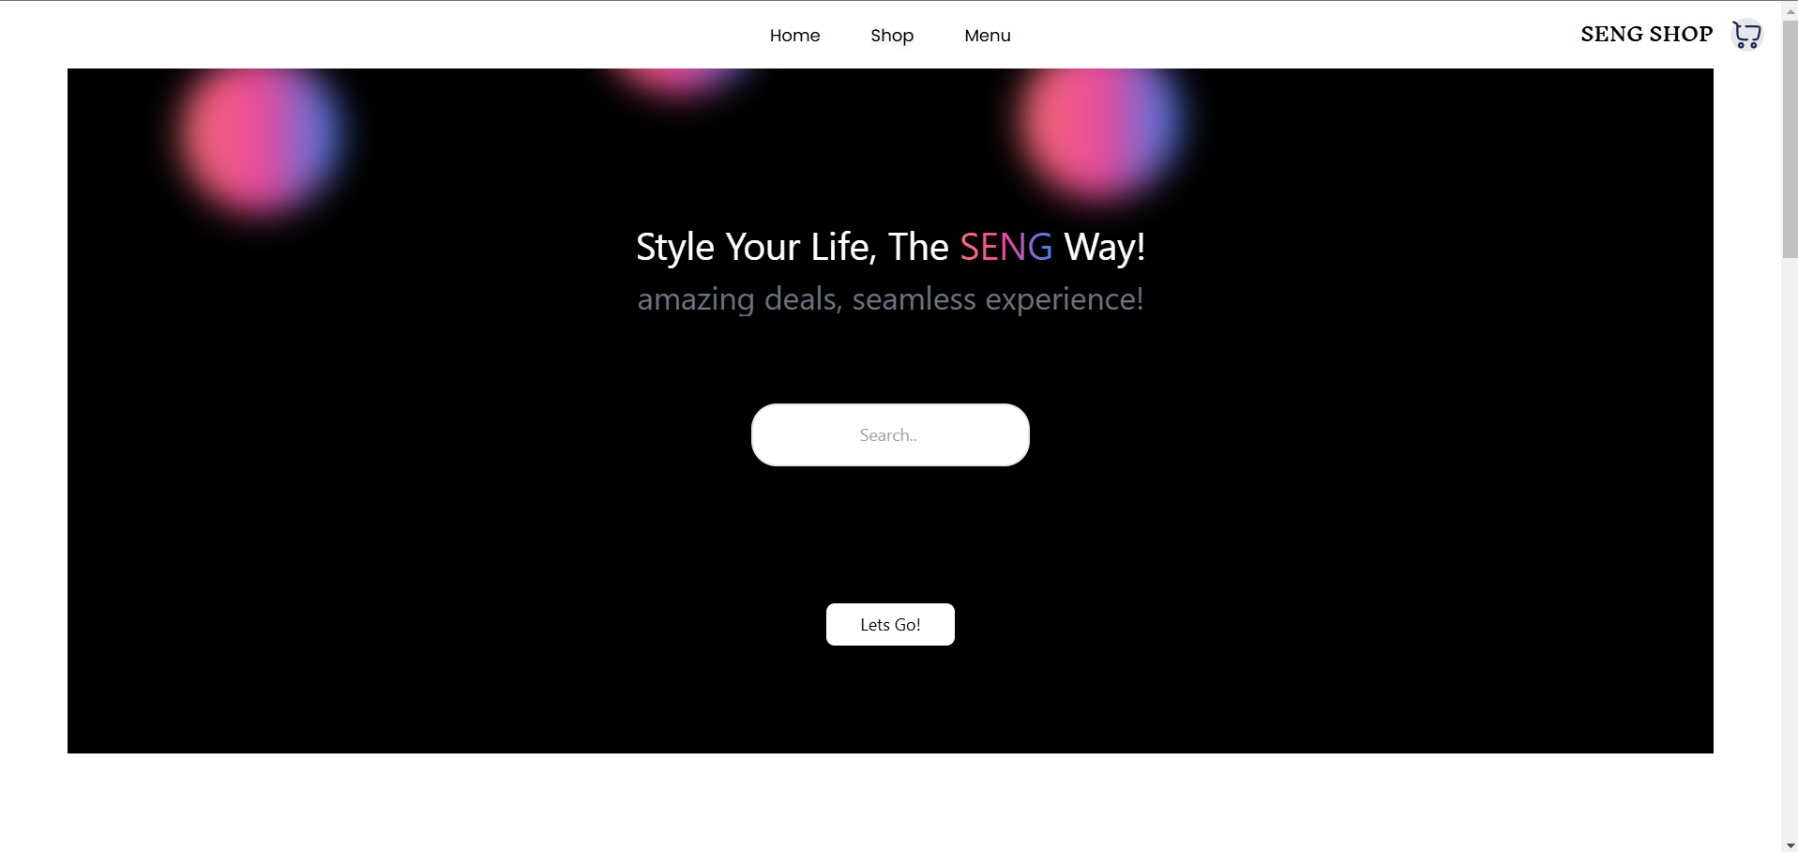

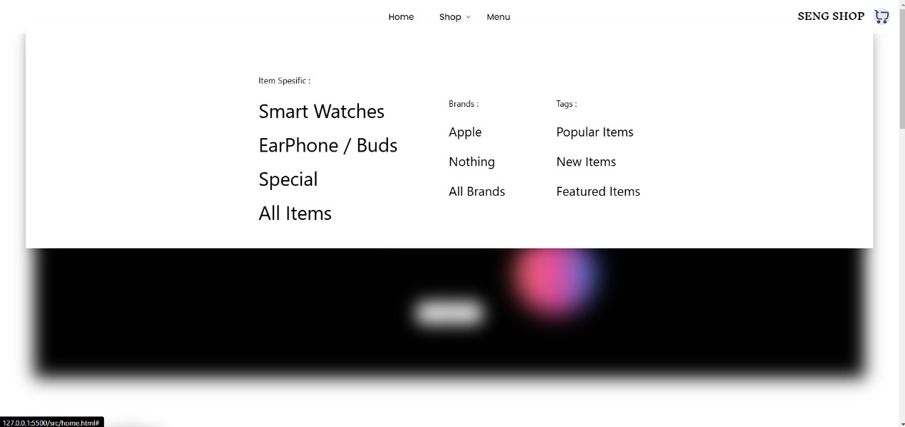

This is the primary menu of our webpage, designed to be user-friendly and interactive. The menu options open automatically when the user hovers over or places the cursor on them, eliminating the need for clicks. This increases interactivity and enhances the user experience by reducing the effort required to navigate.

Additionally, a small down arrow is displayed on the right side of the menu options to indicate that they can be expanded and guiding the user on which menu they have opened.

The typography in the menu is also structured to prioritize important options, with more essential options in larger text and less frequently used options in smaller text.

* 1. Background Blur.

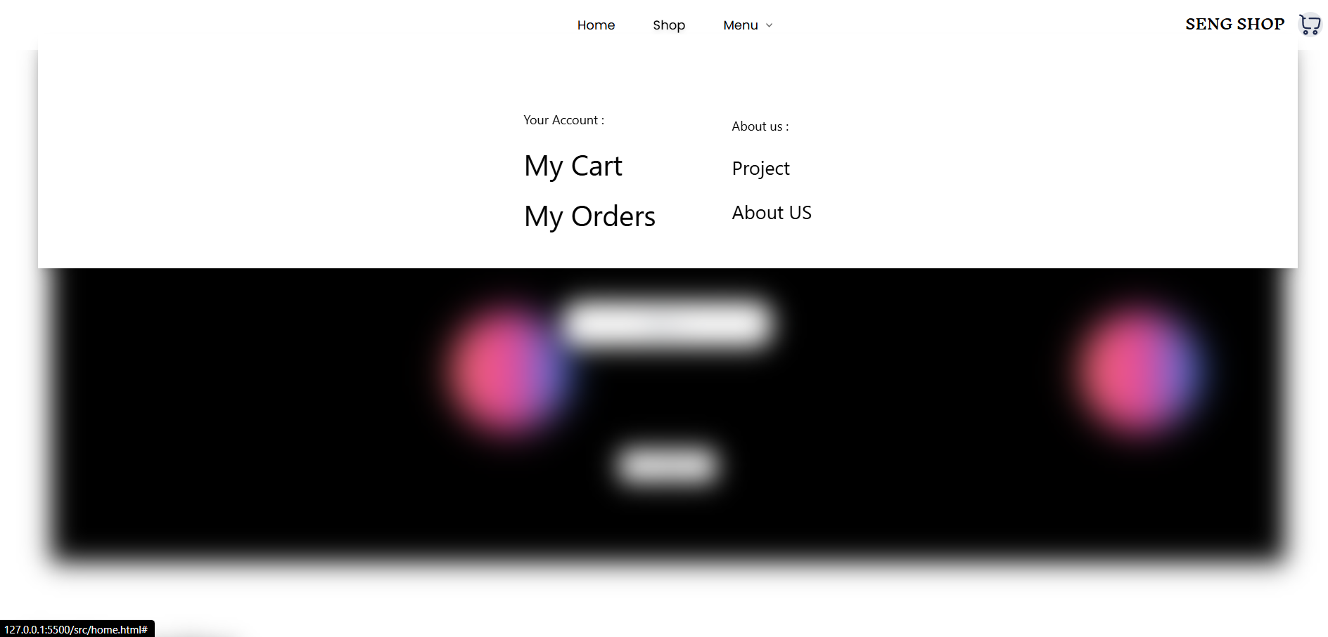

To make the experience more user-friendly, we have adopted a modern approach used by major websites such as [www.apple.com](http://www.apple.com).

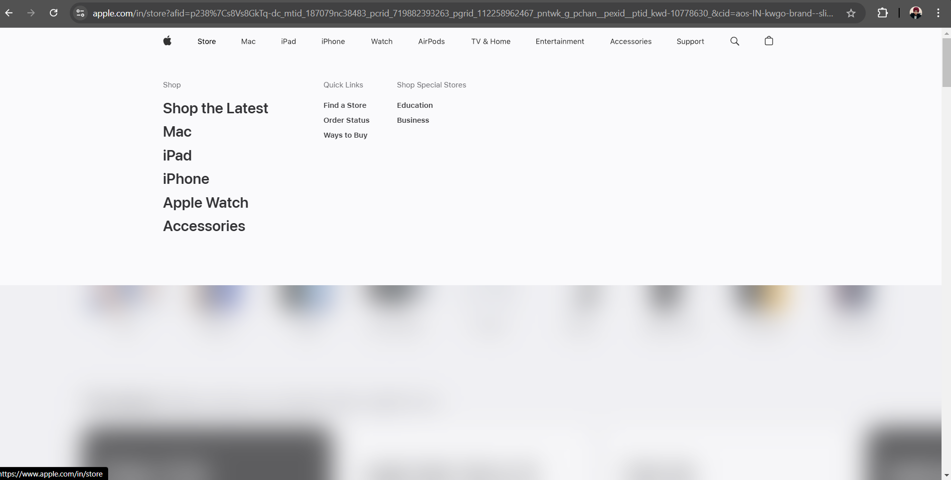

blurring the background content when the menus open. This helps increase user focus on the menu options.

We have implemented this technique in various areas of our website, such as in the menus, item detail viewer, and during the saving processes.

Examples:

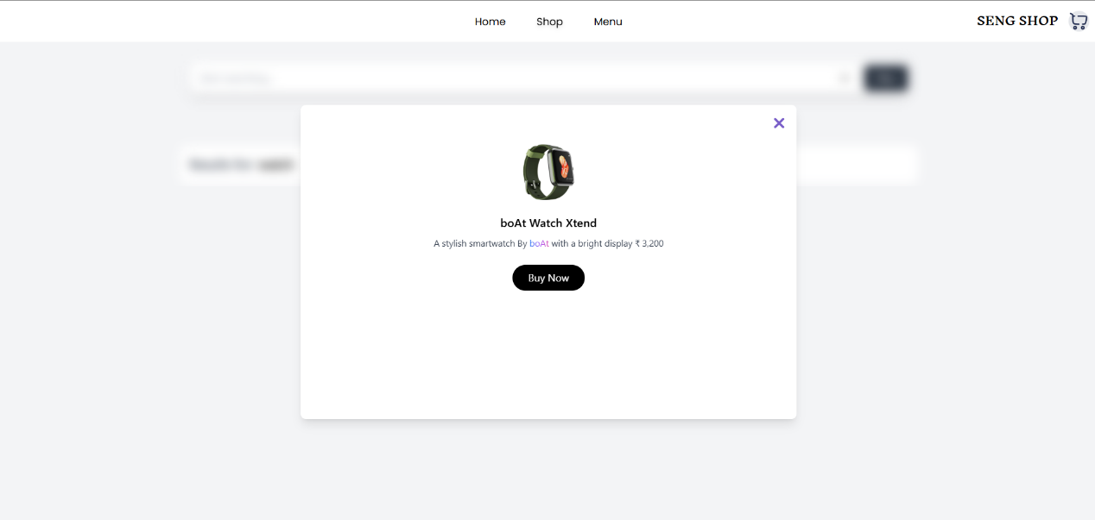

Background blur in Item detail viewer in search function.

Background blur during saving processes.

1.3 Interactive Elements and Animation.

Features like CSS animations, UI animations, hover effects, and scroll animations are also included in this project to enhance usability and interactivity for users on the web page.

Here is an example of a shopping cart icon animation: whenever the user clicks the ‘Order' button, the shopping cart icon performs this animation.



This animation not only looks cool and interactive but also grabs the user's attention, directing it toward the shopping cart icon. It indicates that an action has occurred, encouraging the user to check the shopping cart and proceed with the next step.

Another example is the scrolling animation: when the user scrolls through the webpage, a scale-in animation occurs. This adds an interactive element and provides a visually pleasing experience for the user.

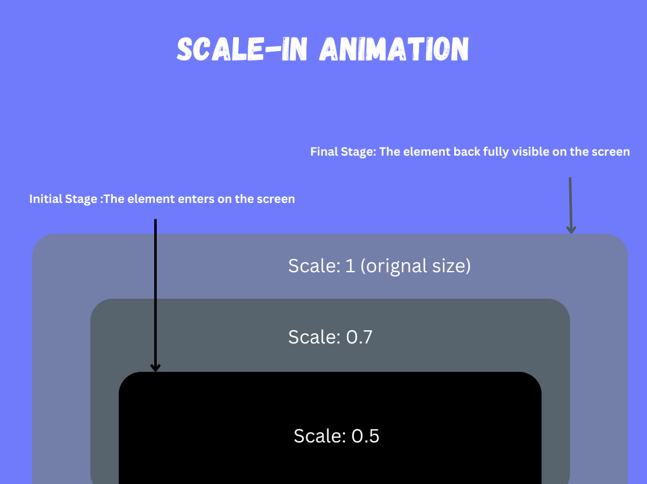

To implement these animations, transitions, and hover effects, we have used CSS and JavaScript, which are widely utilized for creating visually appealing graphics and effects for websites. These animations make our webpages and web content dynamic and interactive.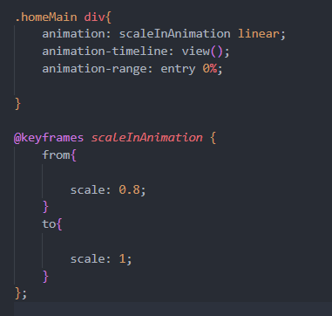

this is the source code for the scale-in animation in the src/style.css file

In this source code, we are targeting the div elements of the homepage's main section and assigning them the scale-in animation.

Another example can be hovering buttons: Project has some hover buttons when the user places their cursor over a button, its appearance changes. This effect is known as a hover effect. It is a widely used transition in CSS.

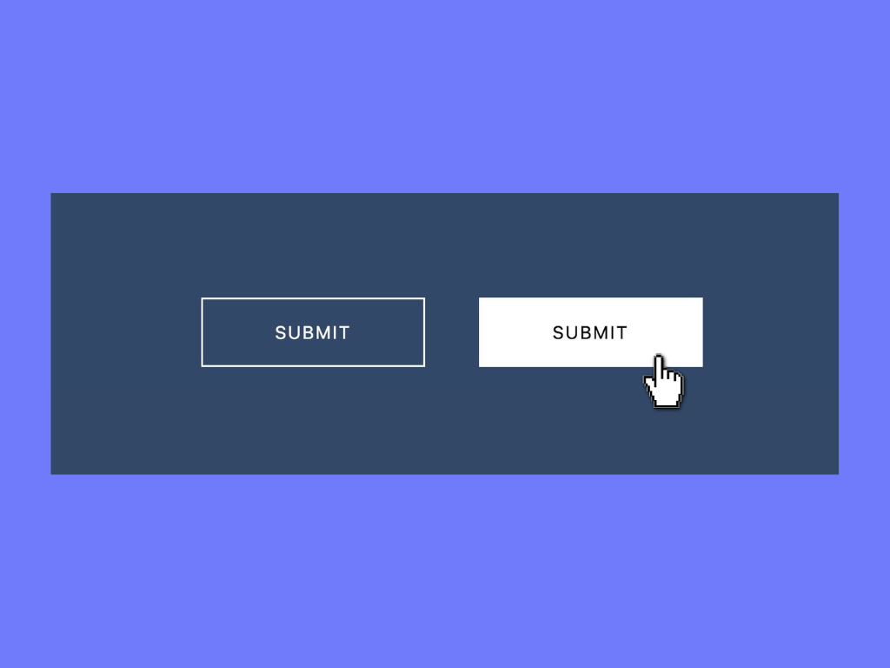

This is an example of a hover effect where the ‘Submit’ button's appearance changes during user interaction.

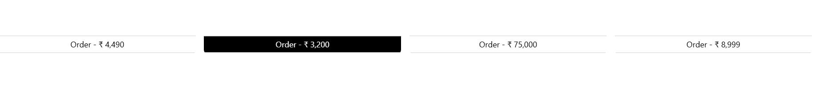

Here is a live example of the hover effect applied to the ‘order’ buttons in this project.

1.4 Top Navigation Bar

The top navigation bar is one of the key feature of user friendly interface of this project, designed to provide easy access to key sections and functionalities of the website. It is present on every page, ensuring consistent navigation throughout the site. The position of the navigation bar is fixed, meaning that it remains stuck to the top of the page, even as the user scrolls. This feature enhances usability by allowing users to quickly access different pages and functions without having to scroll back to the top.

1.5 Quick Navigation.

This project includes navigation buttons that allow users to quickly access specific categories of products. These buttons are an integral part of the user-friendly interface, as they provide quick navigation without the need for extensive scrolling or searching for specific categories. The buttons are labeled clearly as Popular, New, and Featured for easy understanding. A brief description of these buttons is provided below.

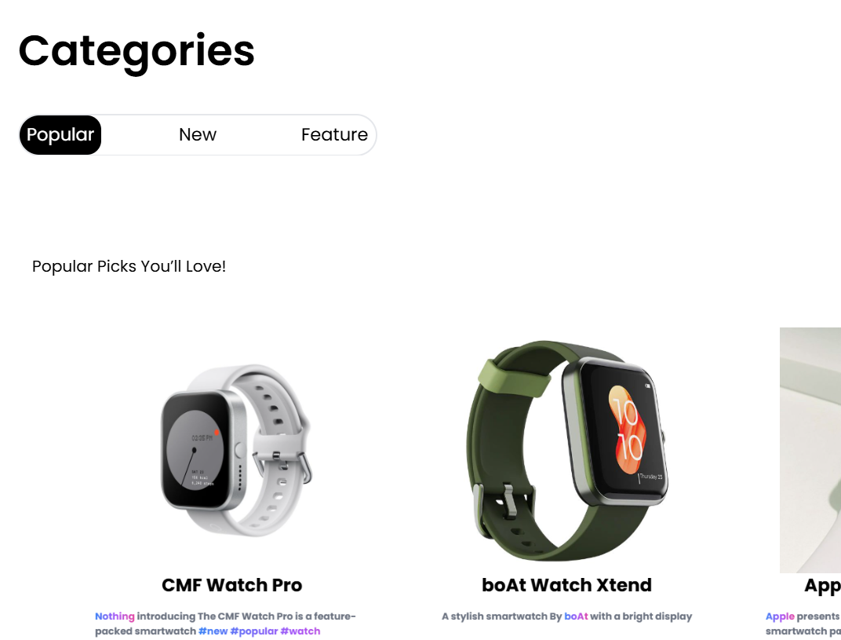

Popular: This button provides users with quick access to products that are trending or most purchased by other customers. It helps users explore high-demand items easily, catering to those who prefer tried-and-tested products.

New: This button directs users to the latest products added to the website, catering to customers interested in the newest trends and technologies.

Feature: This button highlights specially curated items or popular products, ensuring that users can quickly access high-demand or premium offerings.

As an example, this project features the Apple Vision Pro, a virtual reality headset, in the Featured Items category. This product is not typically available on the website but is showcased as a featured item to highlight its exclusivity and appeal. The Featured Items category provides curated products, including bestsellers, exclusive items, seasonal offerings, and recommended products. These curated selections are designed to engage users, attract their interest, and provide them with exceptional offers and deals.

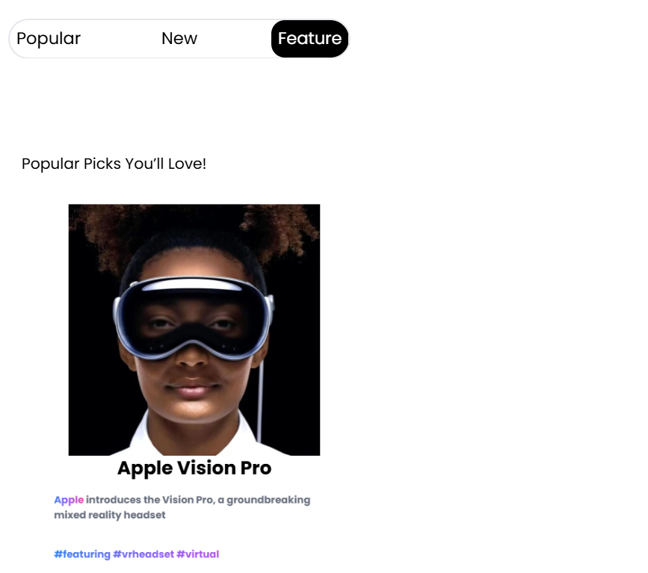

This is how we have selected the most popular product categories and provided users with quick navigation and easy access, helping them save time and enhance their browsing experience.

1.6 Product Presentation.

Product presentation refers to how products are displayed to users on an e-commerce website. The goal is to present the product in a clear, attractive, and informative way that encourages users to make a purchase. Effective product presentation involves not only the visual aspects (such as images, layout, and design) but also the information provided (such as descriptions, specifications, and pricing). A well-designed product presentation enhances the user experience by making it easier for customers to find and evaluate products.

How it was implemented in this project

In my project, I implemented an effective product presentation using product cards. Each product card consists of several key elements:

1. Product Image: A high-quality image of the product that provides users with a clear view of what they are purchasing.
2. Product Title: A bold, black font for the product title, making it easy for users to understand what the product is at a glance.
3. Product Description: A brief description that provides essential details about the product, such as the company name, key features, specifications, and benefits.
4. Tags: Relevant tags, such as "New", "Featured", or "Popular", are displayed after the product description to help users quickly identify special offers or categories.
5. Product Price: The price is clearly displayed alongside the ‘Order Button’, enabling users to easily understand the cost of the item before making a purchase.
6. Order Button: A visible call-to-action button that allows users to easily add the product to their cart or complete the purchase.

A practical example of product presentation in this project is shown below.

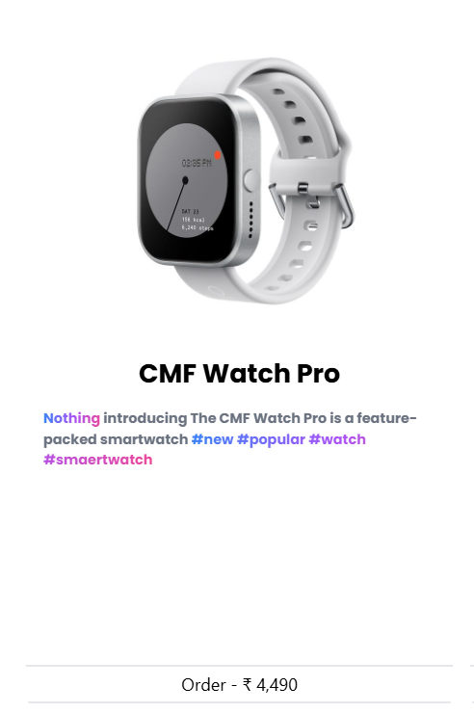

1.7 Typography and Color Design

Typography and color design play a crucial role in enhancing user experience by improving readability, accessibility, and visual appeal. The right use of fonts and colors helps guide users through the content, making key information more noticeable and easy to understand.

For instance, in the product representation of this project, color design and typography are clearly implemented to ensure a seamless user experience, as illustrated in the image above.

This design choice draws attention to key information. For improved readability and user experience, the product title is displayed in bold black font with a larger size, ensuring it stands out clearly for easy identification. The product description is presented in a smaller font size for a clean, concise look. Tags are styled with a hash (#) sign, helping users recognize them as product categories or attributes. Finally, the price is preceded by the rupee sign (₹), providing a clear indication of the cost for better user understanding. The company name and tags are highlighted using a linear gradient effect, making them visually distinct and interactive.

Even the typography and color structure of this website are designed to enhance readability and direct user focus to key elements. The primary font used throughout the site is Poppins, a free and versatile font available on Google Fonts. This font is consistently applied across main headings, subheadings, product titles, and detailed descriptions, maintaining a cohesive look.

fonts.google.com

Google Fonts provides a convenient way to import and use fonts directly in a website's CSS. Developers can integrate a font by copying a link provided by Google Fonts and adding it to their HTML file or importing it into their CSS file. This eliminates the need for downloading and hosting font files manually.

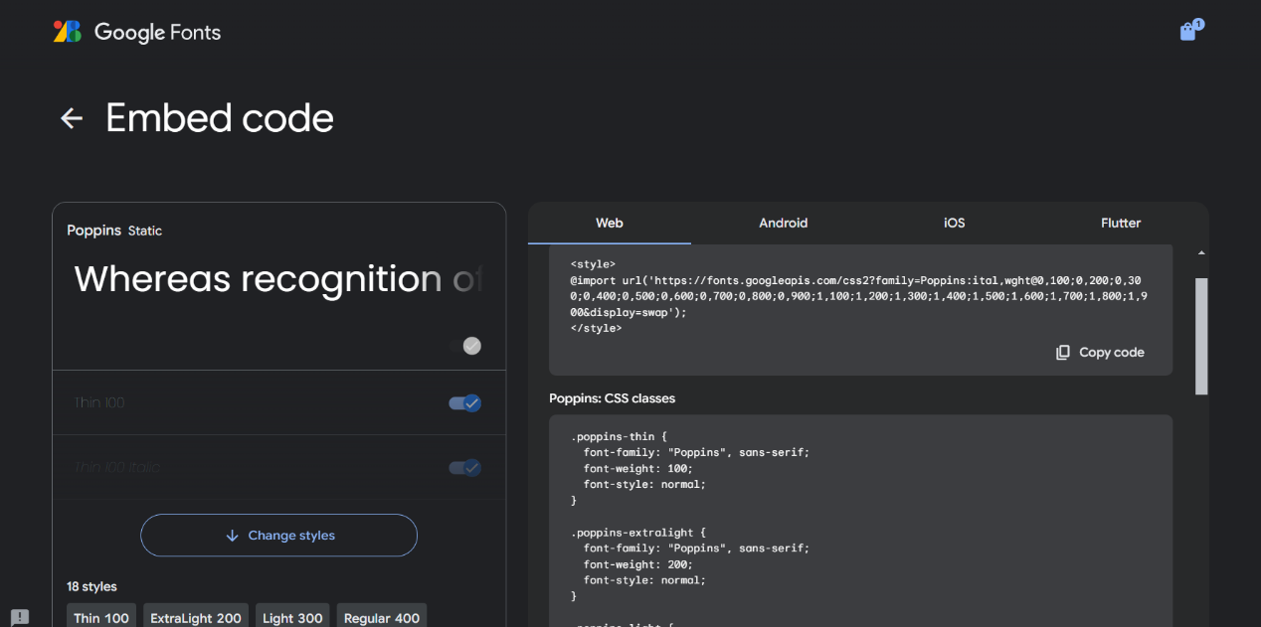

To further improve readability and highlight important information, main headings are styled with a larger font size and bold weight to stand out, while less important headings are displayed in a regular size with a subtle gray color.

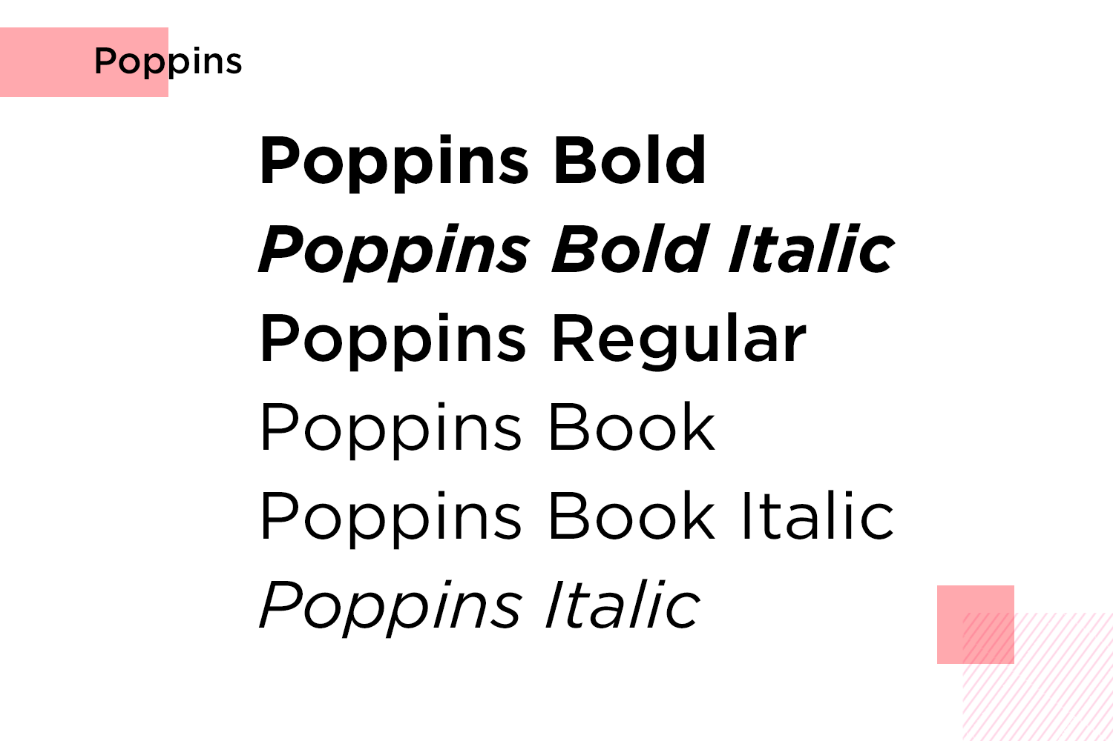

Even though we have applied various font styles, such as thin, thick, bold, and different colors like black and gray, as well as varying text sizes, the typography across the website remains consistent. The entire website uses the Poppins font as the primary text style.

The user-friendly interface and design elements discussed above form the backbone of this web project, ensuring a seamless and intuitive user experience.

## Search Feature:

Now, let’s dive into another key feature of this project: the Search Feature. This functionality plays a critical role in enhancing user convenience by allowing them to quickly locate specific products or categories without browsing through the entire website. Below, we will explore the implementation, design, and functionality of the search feature in detail.

The search function allows users to easily find specific items on the website by typing related keywords into the search bar. Users can search for products using various criteria, such as the company name, product name, color, or category (e.g., earphones, earbuds, smartwatches, etc.). To initiate the search, users simply press the Enter key on their keyboard.

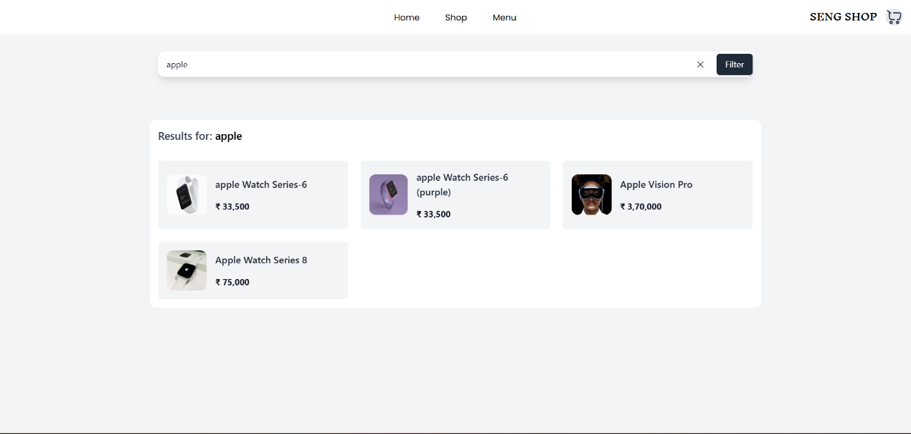

Here is an example of the search feature in action: searching for products related to the Apple company. Upon entering "Apple" in the search bar and pressing Enter, the system retrieves and displays all Apple related products available on the website. From the search results, users can quickly browse the matching products and proceed to purchase their desired item directly.

How the Search Function works

The logic behind this search function is implemented using a JavaScript algorithm. When a user enters their input into the search field or search bar and presses the Enter key, the algorithm searches the user’s input against the descriptions of all products available on the website.

If the entered value matches any part of a product description, whether it is one or multiple products, the corresponding results are automatically displayed on the screen. This allows users to quickly find relevant products without any complex navigation. The search functionality is entirely based on product descriptions, ensuring that users can retrieve items even with partial or descriptive keywords.

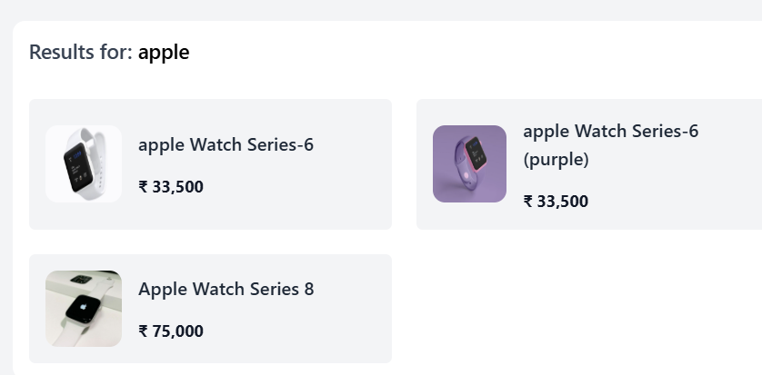

To make the search function more user-friendly, it also displays the user’s searched value along with the results. This ensures that users are always aware of what they have searched for, providing them with clear feedback.

For instance, if a user enters "apple" into the search bar and presses Enter, the page will not only display the matching products but also show the term "Results for: apple". This feature helps users verify their input and navigate through the results more efficiently.

The search feature is designed to be easily accessible to users in multiple ways:

1. On the Homepage: Users can quickly find the search input field in the primary section of the homepage, ensuring that it is immediately visible and easy to use.
2. In the Drop-Down 'Shop' Menu: The search feature is also available as an option in the drop-down 'Shop' menu. By selecting this option, users are directed to a dedicated search page, where they can enter their query and view results.

These multiple access points ensure that users can utilize the search functionality regardless of their location on the website.

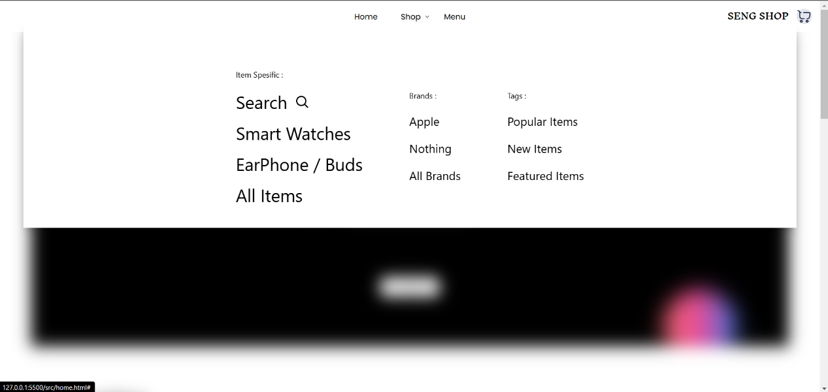

Future Update:

To further enhance the search feature, we are planning to introduce a filter functionality. This addition will allow users to narrow down their search results by applying specific filters, such as price range, product category, brand, or availability.

This feature is particularly beneficial for websites with a large number of products, as it helps users quickly find exactly what they are looking for.

To enhance user accessibility, users can select and directly add products to the cart from the search page. After searching for a product, users can click on the desired item in the search results. A dialog box will appear, displaying the product details along with a "Buy Now" button. By clicking this button, users can instantly add the product to their cart.

Below is an example demonstrating how users can add items directly to the cart from the search page

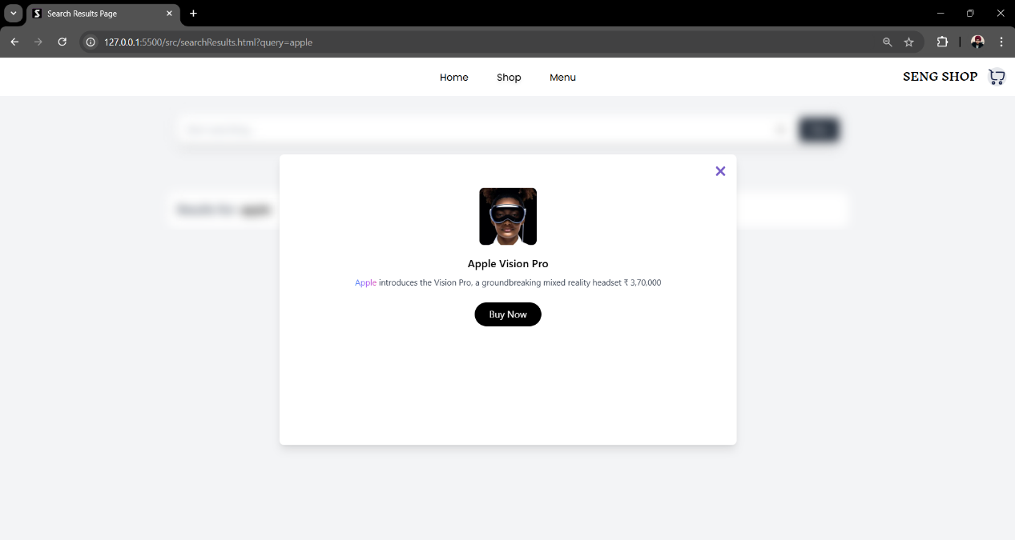

## Product Cart Preview

The Cart Preview feature is an essential addition to this project, designed to enhance user convenience and streamline the shopping experience. This feature displays a small window on the right side of the webpage.

The cart preview allows users to view the products they have added to their cart without needing to navigate to the ‘Order Summary’ page repeatedly. It provides essential details about the selected items or products, including:

1. Product Name
2. Product Quantity
3. Total Amount: The combined cost of all selected products in the cart.
4. Total Products: The total number of items the user has selected to purchase.

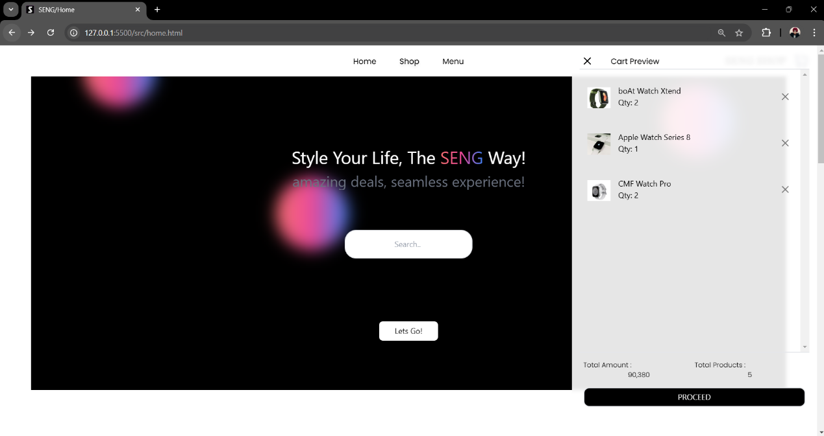Additionally, users have the control to delete items directly from the cart preview, offering greater control and convenience. This eliminates the need to visit to the ‘Order Summary’ page multiple times, allowing users to easily manage their selected items while browsing the website.

This image illustrates how the feature is displayed on the website.

Accessibility of the Cart Preview Feature

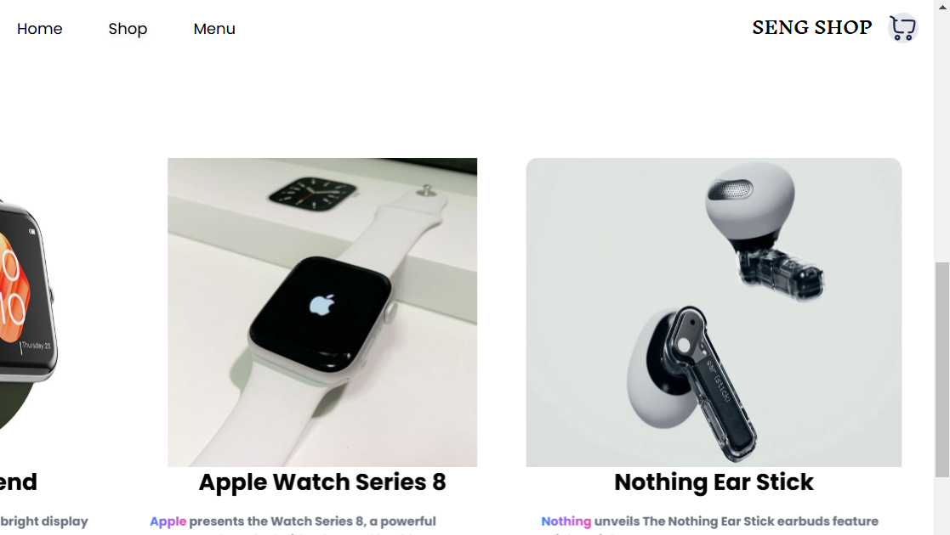The Cart Preview feature is designed to be easily accessible from any part of the website. Users can quickly access this functionality by clicking on the shopping cart icon located in the top main navigation bar. This consistent placement ensures that users can view and manage their selected items seamlessly, regardless of which page or section of the website they are currently browsing.

This is the example where we can see the small shopping cart icon located in the top navigation bar. Clicking this icon opens the Cart Preview window

Top Navigation Bar

The top navigation bar is one of the key feature of user friendly interface of this project. It is present on every page, ensuring consistent navigation throughout the site.

Due to the navigation bar being present on every page of the website, users can easily access the product card preview function at any time, regardless of which page they are on.

For example, after searching for items and adding them to the cart on the search page, users can quickly check what they have added by accessing the cart preview directly from the top navigation bar. This feature saves users time and effort by allowing them to view and manage their cart without needing to navigate to ‘Order Summary’ or home page.

Below is an example demonstrating how this functionality works.

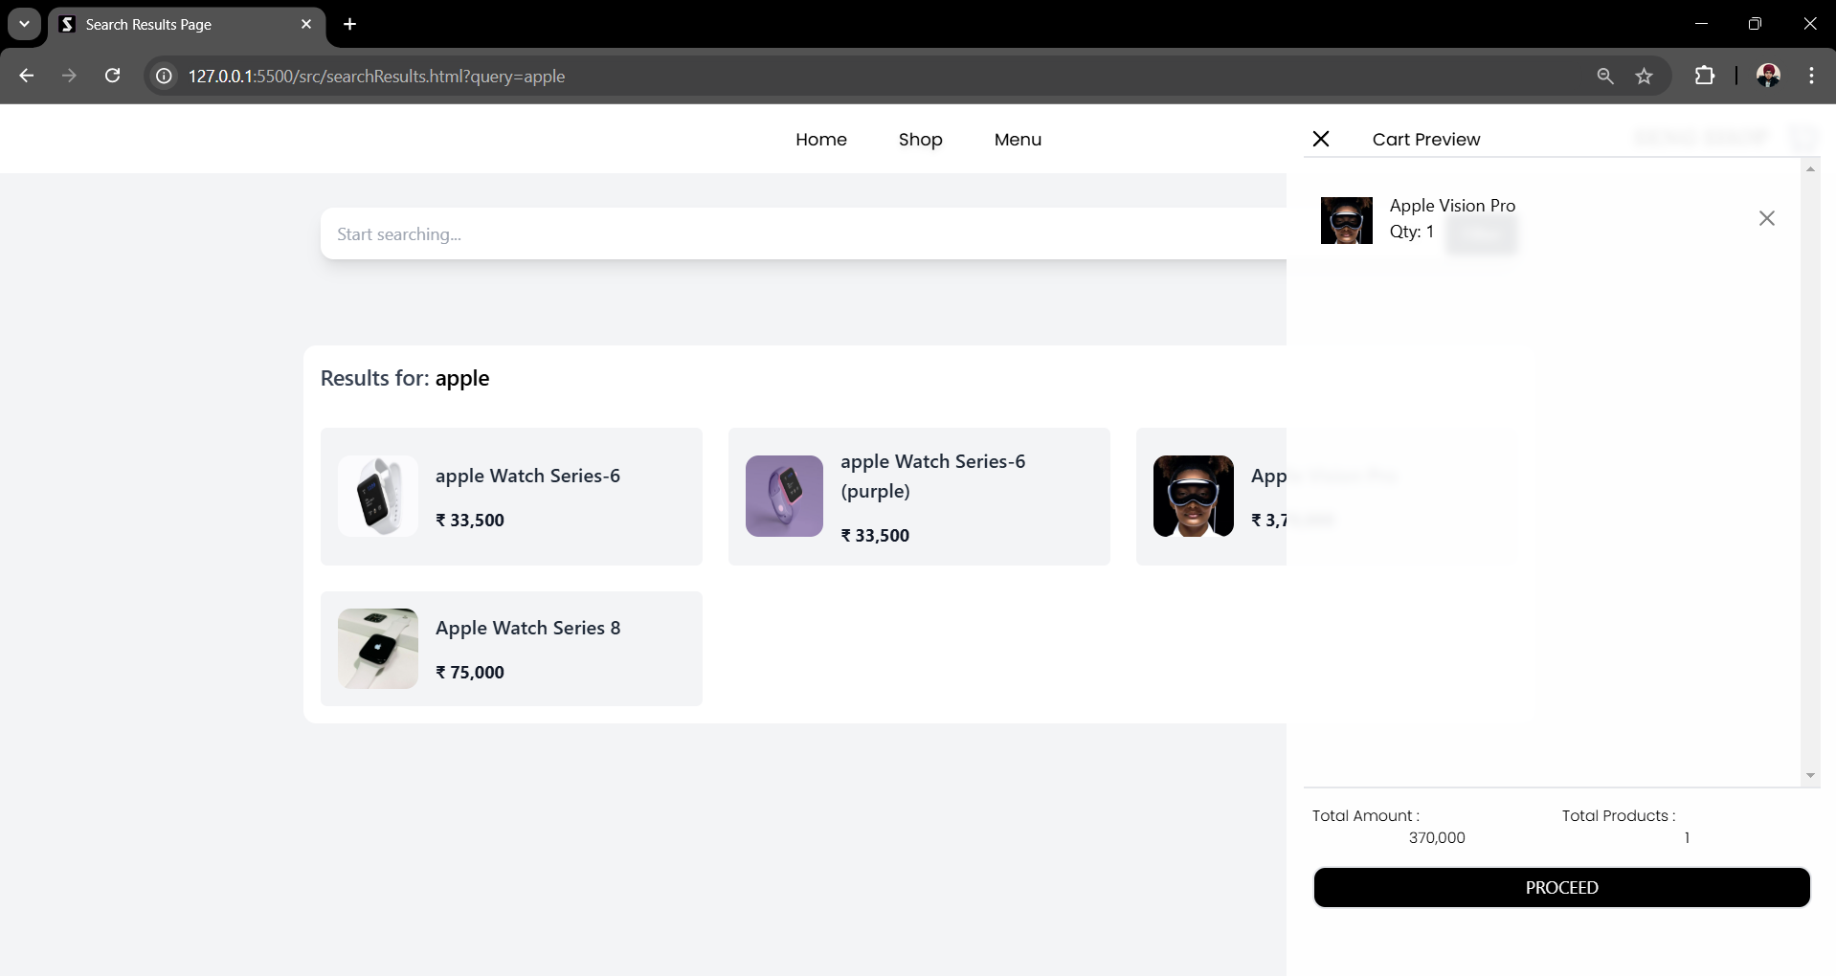

## Shopping Cart

The shopping cart is one of the essential features of this project, designed to allow users to manage products they intend to purchase. It acts as a virtual basket where users can add items while browsing the website, keeping track of their selected products until they are ready to proceed with the checkout process.

This feature is crucial for providing a seamless shopping experience, enabling users to manage their purchases by updating quantities, removing items, or viewing the total cost before finalizing their order.

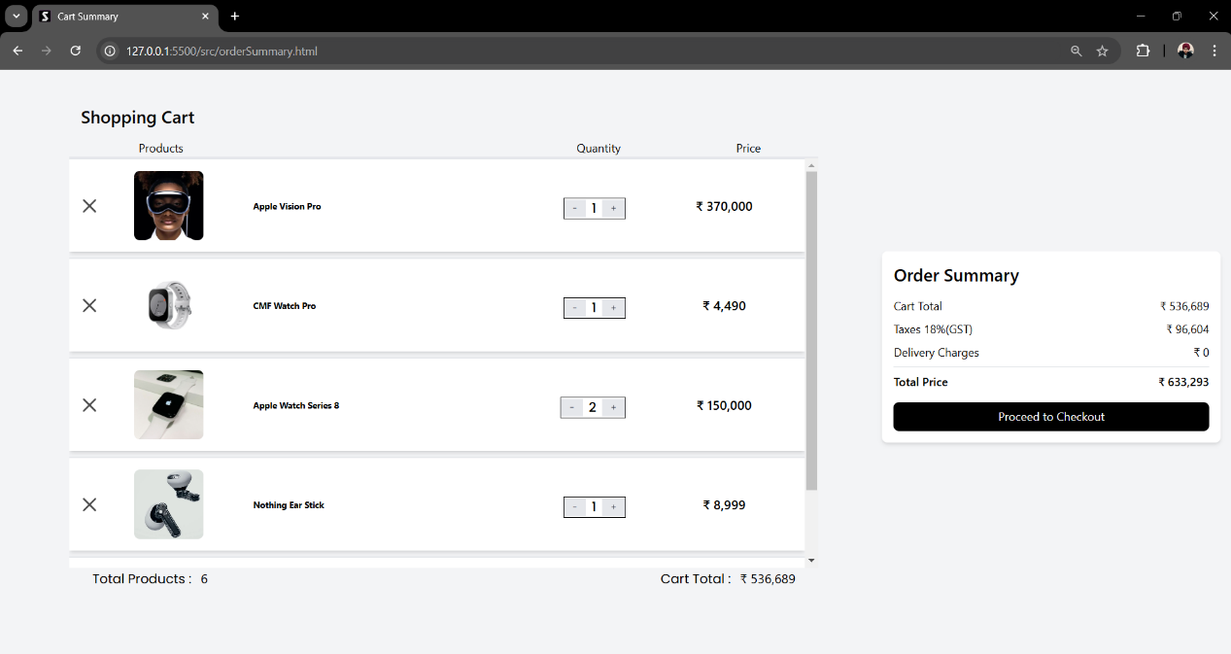

This is a live example or demonstration of the shopping cart feature from our project, showcasing how different products have been added to the cart. This step occurs after the user selects all the items they intend to purchase but before finalizing their order. It provides users with an opportunity to review and finalize their products before proceeding to the final checkout process.

Our shopping cart provides several features, users can use:

1. Increase or decrease the quantity of selected products.
2. Delete any item from the cart if they no longer wish to purchase it.
3. View the price of individual items and the total amount for all items in the cart.
4. See the total number of items in their cart.

Accessibility of the Cart Preview Feature

The shopping cart feature is easily accessible through multiple ways:

1. From the Product Cart Preview: Users can directly visit the shopping cart feature by clicking the "Proceed" button located at the bottom of the product cart preview window.
2. From the Top Navigation Bar: Users can access the shopping cart feature by selecting the "Menu" option and then clicking on "My Cart."

Both of these options take the user to the Order Summary Page, where they can utilize the shopping cart features, such as managing their selected items, and explore additional options available for the checkout process.

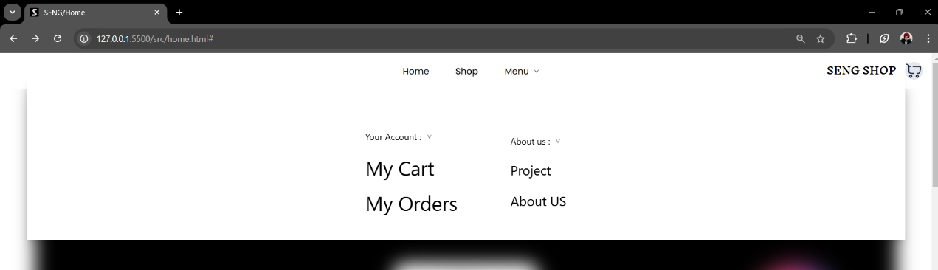

This is a demonstration of how to access the shopping cart from the top navigation bar.

Flexibility of the Shopping Cart Feature

The shopping cart feature is designed to handle a large number of items seamlessly, providing flexibility and convenience for users who select multiple products. This feature includes a scrolling functionality, allowing users to navigate through their selected items easily.

When a user has added too many items to the cart, they can simply scroll to view products that are not immediately visible in the current viewport. This scrolling feature ensures a smooth and consistent user experience, enabling users to manage their items effectively without overwhelming the interface.

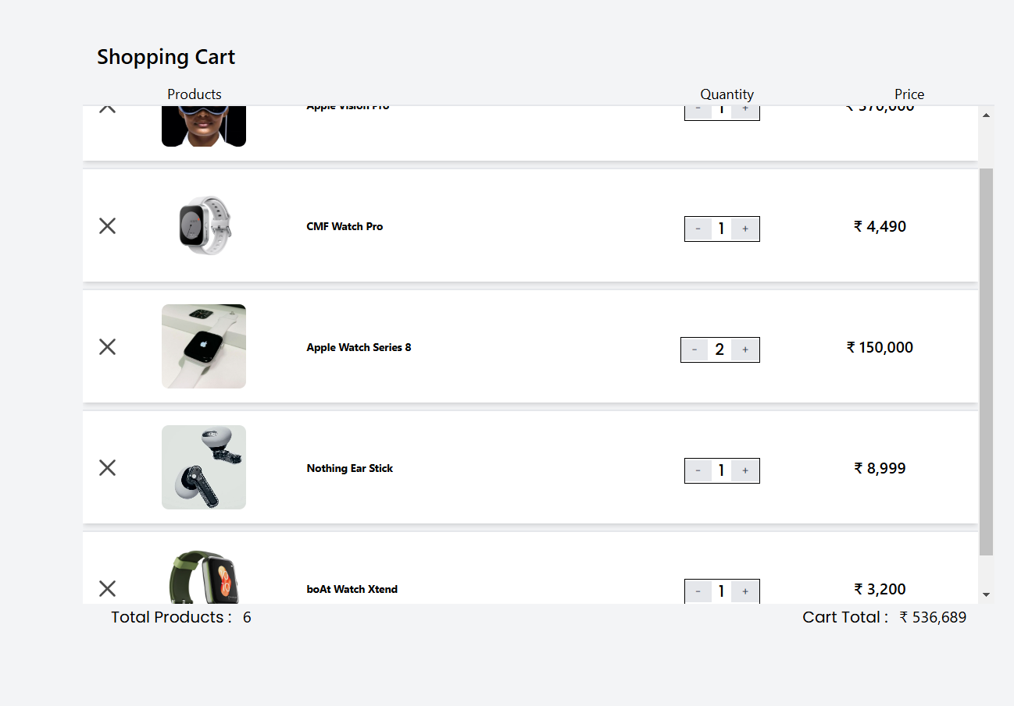

Additionally, this feature benefits developers by maintaining the layout and design consistency of the shopping cart, regardless of the number of items. This flexibility enhances the overall user-friendly environment of the website.

Typography in the Shopping Cart Feature

As seen in the previous demonstration, In the shopping cart feature, no special font styles are applied to the text or numerical data. The only exception is the main headings, where the Poppins font is used, which is the standard font style applied throughout the website to maintain consistency.

This design choice was made intentionally to keep the focus on the essential information, such as the total amount and total number of products, without distractions from excessive styling. The use of the default font for most content ensures clarity and easy readability for the user.

* 1. Order Summary Section (Bill)

The Order Summary section, located alongside the product card feature on the same order summary page, is another key component of the shopping cart feature. This section is crucial in e-commerce websites as it provides users with a clear overview of their final order details.

It includes essential information such as:

1. Total Cart Amount
2. Taxes Applied
3. Delivery Charges
4. Final Total (including taxes and delivery charges)

By displaying this breakdown, the order summary ensures that users are fully informed about the cost of their purchase before they proceed. This transparency helps users make informed decisions and provides them with a clear understanding of the final amount they will pay.

The demonstration of the Order Summary Section (Bill) is provided below.

In the Order Summary Section, the information is presented in a clear, structured format with two main columns:

1. First Column: This column lists the details of the charges or fees. It provides labels such as Total Cart, Taxes, Delivery Charges, etc.
2. Second Column: This column displays the corresponding numerical values for each charge mentioned in the first column.

This helps users easily compare and understand the breakdown of their total order cost.

Additionally, to maintain simplicity and clarity, no fancy fonts or excessive styling are applied, allowing users to focus on the essential information without distractions.

A "Proceed to Checkout" button is located in the Order Summary Section, set against a black background. When clicked, the user continues the purchasing process and is directed to the shipping form to place their order. This action occurs only after the user has reviewed and is satisfied with the items they wish to purchase.

The placement of the Proceed to Checkout button in the Order Summary Section is intentional. It ensures that the user reviews the full details of their orde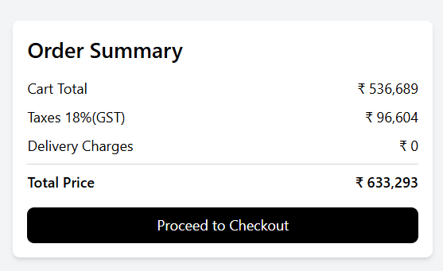r before proceeding.

That concludes the explanation of the Order Summary Page, where users can take advantage of the shopping cart feature to view important details about their selected products and finalize their purchase.

Future Update:

Currently, the order summary functionality relies on the local storage feature provided by JavaScript. While this approach is convenient, it is not the most secure method for handling sensitive information.

To enhance security and protect user order details, we plan to implement stronger protective mechanisms in the future, typically found in back-end web development, to ensure a higher level of security for user data.

## Shipping Form

Let’s discuss another key feature of this project: the Shipping Form. This form appears when the user clicks on the "Proceed to Checkout" button from the Order Summary Page after verifying their order and deciding to place it.

Upon clicking the button, the user is directed to the Checkout Page, where they encounter the Shipping Form. This form is an essential step in the purchasing process and must be completed before placing an order. It collects the necessary shipping details to ensure the successful delivery of the products.

Now, let’s dive into the details of this feature.

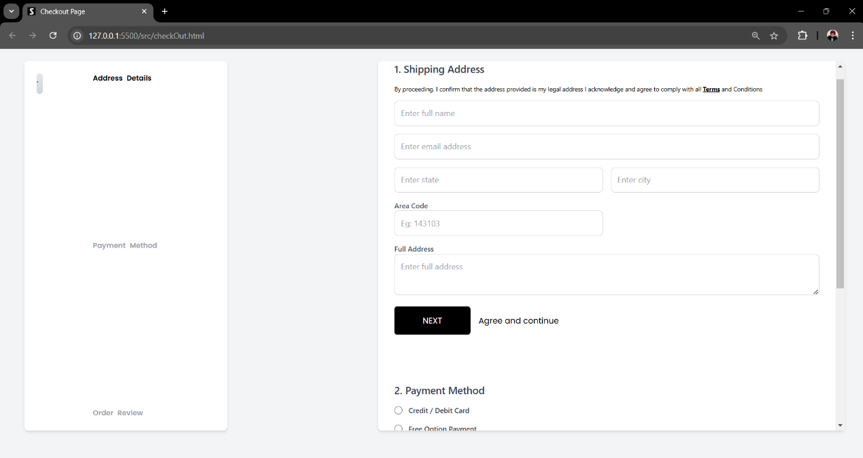

This is a demonstration of the Checkout Page and the Shipping Form, showcasing their layout and design.

On the Checkout Page, there are three key components:

1. The left side features the Progress Section.
2. The right side displays the Shipping Form
3. Terms and conditions

Let’s discuss both of these components in detail, one by one.

Shipping Form:

The Shipping Form is a critical component of the checkout process, designed to collect essential delivery details such as the user's name, address, contact information, and any specific instructions for the shipment. It ensures accurate and timely delivery of the purchased items to the correct location. Without this form, it would be impossible to process orders and facilitate product delivery, making it a important step in completing the e-commerce transaction.

On our Checkout Page, the Shipping Form is located on the right side of the page. This form consists of several input fields that users must fill out carefully, correctly, and completely.

Our Shipping Form is designed to guide users through three essential stages:

1. Address Stage: In this first stage, the user is required to fill in their delivery details, including their address, contact information, and other necessary details.
2. Payment Option Stage: Once the address is completed, the user moves to the second stage, where they select their preferred payment method.
3. Order Review Stage: In the final stage, the user reviews their complete order, including item details, costs, and delivery information, before proceeding with the last step of placing the order.

This structured process ensures that users complete all required steps efficiently and with accuracy.

5.1 Address Stage

This stage includes fields for the Full Name, Email Address, State Name, City Name, Area Code, and Full Address, all of which the user needs to enter manually. Once all the required fields are properly completed, the user can proceed by clicking the Next button, located just below the address section of the form, to agree and continue with the process.

Once the user fills in their address fields correctly and clicks on the Next button, the entered address is saved successfully. Users can also make changes to their address, if needed, by clicking on the Edit Address button. However, all changes to the address must be made before reaching the final stage of the checkout process.

Below is a demonstration of how to fill out the address section of the shipping form.

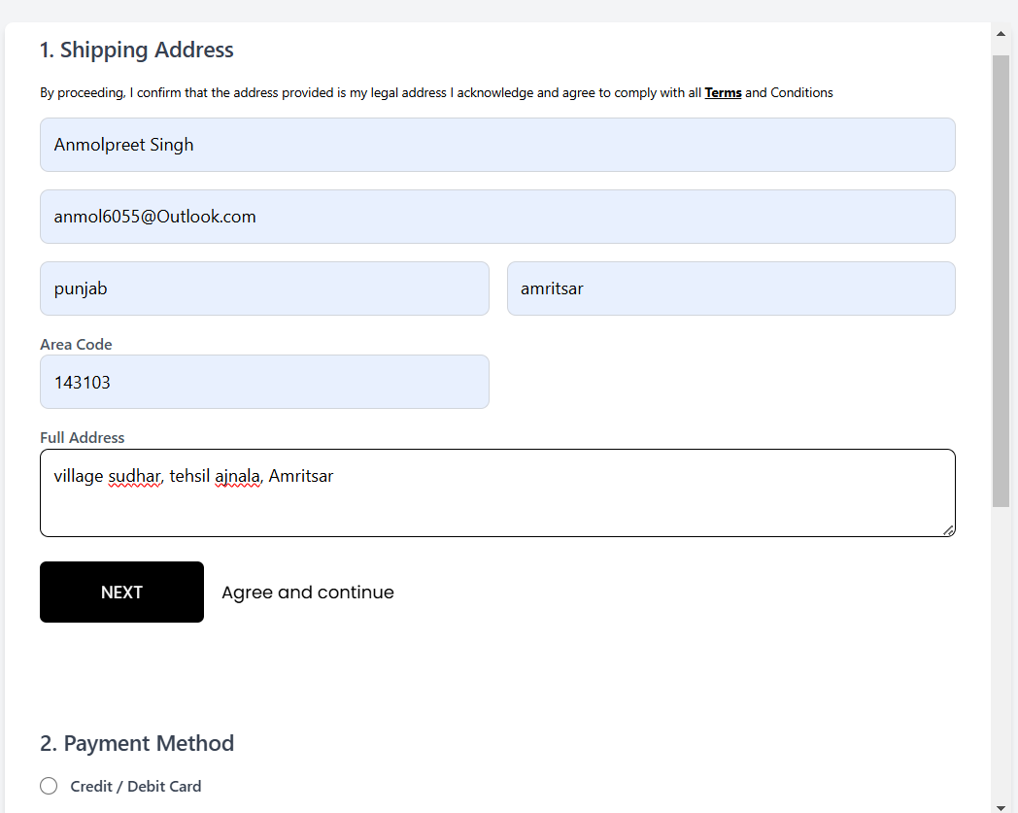

Now, let's discuss some constraints and rules applied to the address form in this project.

1. Mandatory Fields: The user cannot skip any input field without filling it, as all fields are marked as required.
2. Minimum Input Length: Each input field has a minimum character limit, ensuring that users provide sufficient details as per the instructions.

Below is a demonstration of how the address form displays warnings if the user leaves any input field empty.

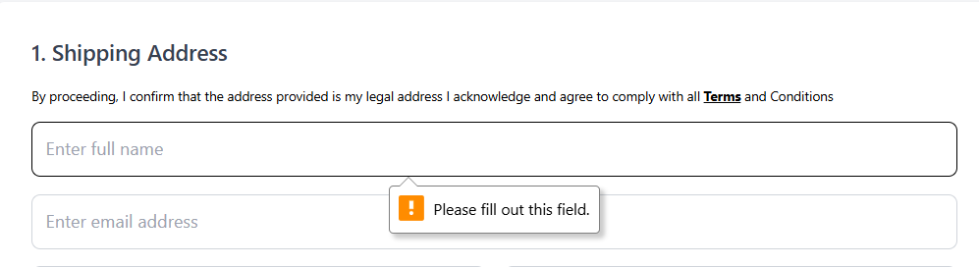

This error occurs because the HTML of this form is configured to mark input fields as required.

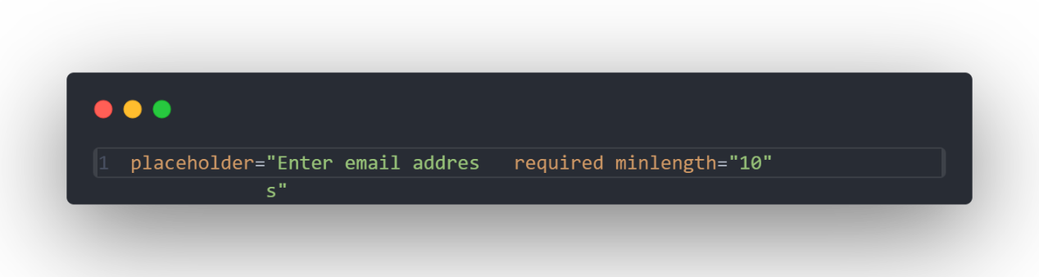

This demonstration shows the HTML code for the email input field, where the required attribute ensures the field cannot be left blank, and the minlength attribute enforces a minimum length of 10 characters.

5.2 Payment Option Stage

After the user successfully fills out the address form, the next step is selecting payment options from the shipping form.

Payment options are an integral part of the checkout process, allowing users to choose their preferred method for completing the transaction. There are numerous payment options available for completing transactions on e-commerce websites, such as credit cards, debit cards, net banking, online wallets, and, in India, the increasingly popular UPI payment method. These options provide users with flexibility and convenience during the checkout process.

However, since this project primarily focuses on front-end development, implementing complex payment systems like UPI or net banking is beyond its scope at this stage. Although, we are planning to explore and integrate such advanced payment options into the project in the future to enhance its functionality.

Currently, our project offers two basic payment options:

1. Credit/Debit Card – A standard payment method where users can enter their card details to proceed.
2. Free Payment Option – A simple and pre-configured option we implemented for demonstration purposes.

These ready-made payment options are sufficient for showcasing the functionality while maintaining simplicity in this front-end-focused project.

In this project, we have implemented basic payment options using radio buttons for easy selection. Users can select their desired payment method by checking the corresponding radio button.

Once the payment option is selected, the user proceeds to the third and final stage of the shipping form, which involves reviewing their order before placing it.

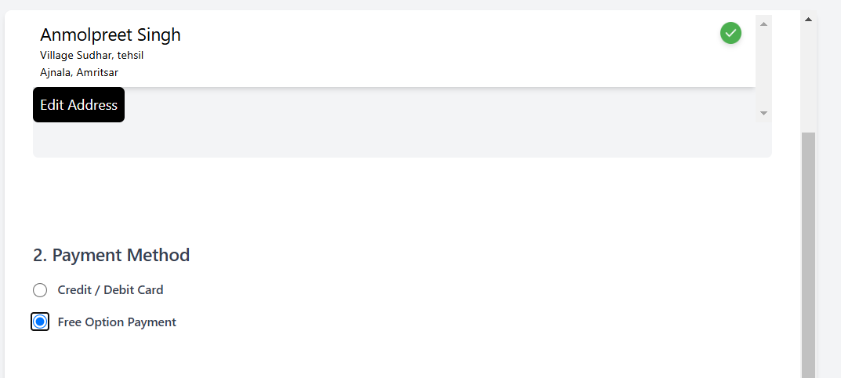

This is the demonstration showcasing how a user selects a payment option in this project

5.3 Order Review Stage

After the user has selected their desired payment method, they will proceed to the final step: the "Review Order" stage. In this step, the user can review their entire order before placing it. This includes details like the total amount, the number of items in their cart, and the selected payment method. If the user is not satisfied with their order or needs to make changes, they can click the "Edit Order" button, which will take them back to the order summary page. Here, they can modify their order, update the quantities, or even change the items. Once the user is satisfied and ready to finalize the purchase, they can proceed by clicking the "Place Order" button at the bottom of the shipping form to complete the order.

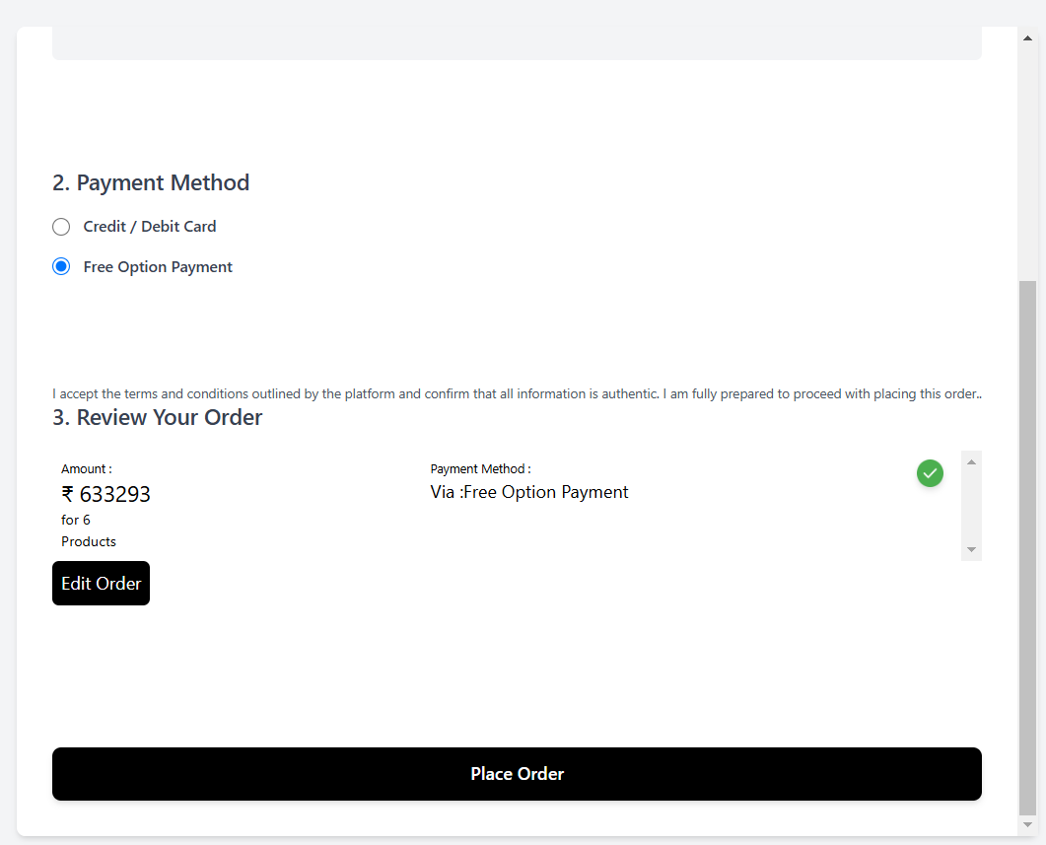

This demonstration showcases how the order review stage looks, where the user can review their order details.

The form is designed in a simple and minimalistic way, without excessive styling or colors, to avoid distracting the user.

## Progress Section

Another important feature of this project is the Progress Section, located alongside the shipping form on the checkout page. This section helps users track their progress through the shipping form by providing a clear visual indication of which stage they are currently at. The progress section consists of two main components:

1. Progress Bar: As the user fills out each part of the shipping form, the progress bar length increases, providing a dynamic representation of their progress. This helps the user understand how much they’ve completed and how much is left in the form.
2. Stage Name: Along with the progress bar, the stage name is displayed, indicating which specific step in the shipping process the user is currently on (e.g., Address, Payment, Review).

This progress section improves the overall user experience by giving users a sense of control and clarity about their current position within the checkout process, motivating them to complete the form efficiently.

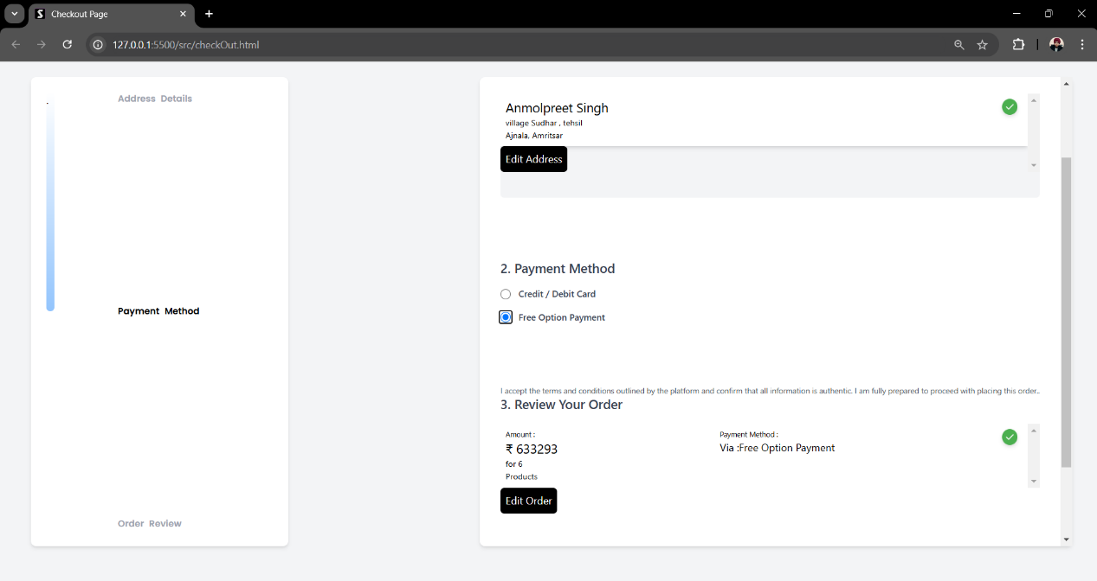

This demonstration showcases how the progress section works on the checkout page. The progress bar dynamically fills up as the user moves through the stages of the shipping form

Animation of Progress Section

When the user moves from one stage to another in the shipping form, the progress bar starts increasing from upward to downward, changing its color from gray to blue. This color transition visually indicates to the user that they are progressing towards the end and helps them understand how much of the form is left to complete. Alongside the progress bar, the stage name also changes color from gray to dark black, indicating to the user which specific stage they are currently on. Below is the demonstration of the complete animation of this progress section. This design and style are intended to catch the user's attention and provide a more engaging and clear user experience.

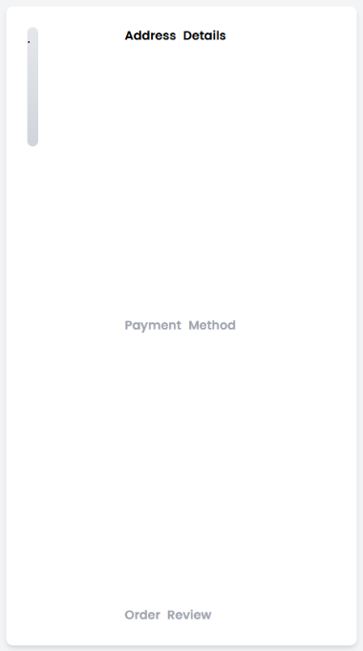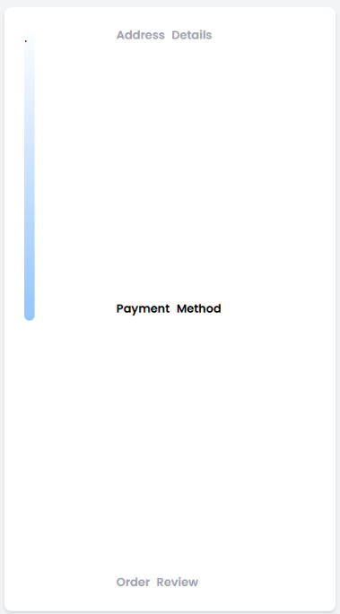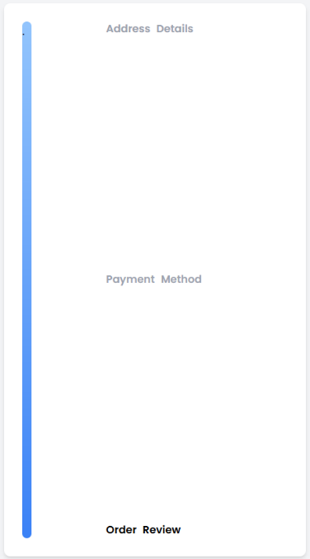

For the mobile version, the progress section has been simplified to accommodate smaller screen sizes while still providing the user with an understanding of their current stage in the process as shown below.

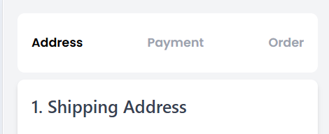

## Terms And Conditions

The Terms and Conditions (T&C) are essential for any e-commerce website, including our project, as they set the legal rules, rights, and responsibilities of both the website owner and the users.

We have also added consent statements or agreement statements at each step of the shipping form on behalf of the user, and it is recommended that users read these statements before proceeding further. These statements are crucial as they ensure that users acknowledge and agree to the terms and services or policies before continuing with their transactions or filling out the form. This helps in providing transparency and ensuring that users are fully informed about the terms they are agreeing to before finalizing their order.

When the user clicks on the Proceed to Checkout button on the Order Summary page, they are first redirected to a Terms and Conditions page. This step ensures that both the user and the platform are legally protected during the transaction process.

On the Terms and Conditions page, users are presented with the complete set of terms and conditions governing the use of the website and the purchase process. It is strongly recommended that users read these terms carefully to fully understand their rights, responsibilities, and obligations.

Users are then given the choice to either:

1. Accept the Terms and Conditions: By doing so, the user agrees to proceed further to the Checkout page to complete their order.
2. Decline the Terms and Conditions: If the user declines, they will be redirected back to the previous page (Order Summary), and they will not be able to continue with the checkout process until the terms are accepted.

This mechanism ensures clarity and legal compliance while maintaining a transparent and user-focused experience. Below is the visual representation of the Terms and Conditions page. It showcases how users are presented with the platform's terms and conditions in a clear and organized format.

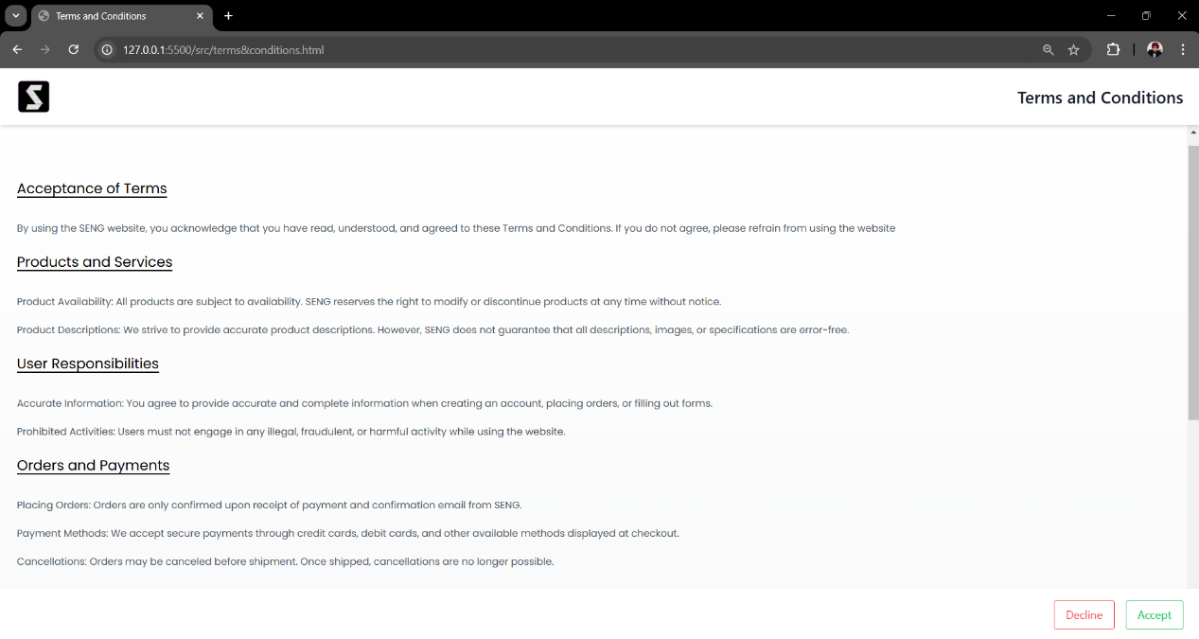

Visual Representation

On the top left side of the Terms and Conditions page, the SENG logo is prominently displayed, representing the brand of the website. On the top right side, a large title "Terms and Conditions" is clearly visible, making it immediately obvious to the user what this page is about.

At the bottom of the Terms and Conditions page, users are provided with two distinct choice buttons:

1. Decline: Highlighted in red, this button signifies the user's decision to reject the terms and conditions.
2. Accept: Highlighted in green, this button indicates the user's agreement to proceed with the outlined terms and conditions.

These visually distinct buttons make it easy for users to understand their options at a glance. Additionally, all terms and conditions are presented in list format, ensuring clarity and ease of understanding. This design approach ensures that users can quickly review and interact with the page without confusion.

Once the user agrees to the terms and conditions by clicking the "Accept" button, they are redirected to the Checkout Page to complete the order process.

Some of the terms and conditions form our project are given below:

1. Acceptance of Terms

By using the SENG website, you acknowledge that you have read, understood, and agreed to these Terms and Conditions. If you do not agree, please refrain from using the website.

2. User Responsibilities

1. Accurate Information: You agree to provide accurate and complete information when creating an account, placing orders, or filling out forms.
2. Prohibited Activities: Users must not engage in any illegal, fraudulent, or harmful activity while using the website.

3. Governing Law and Dispute Resolution

These Terms and Conditions are governed by the laws of [Insert Jurisdiction]. Any disputes shall be resolved through arbitration or in the courts of [Insert Jurisdiction].

These are just a few examples of the terms and conditions from our page. There are many more terms outlined for e-commerce businesses. Additionally, some key terms and conditions are also displayed near the input fields on the shipping form to remind users of the important policies as they proceed.

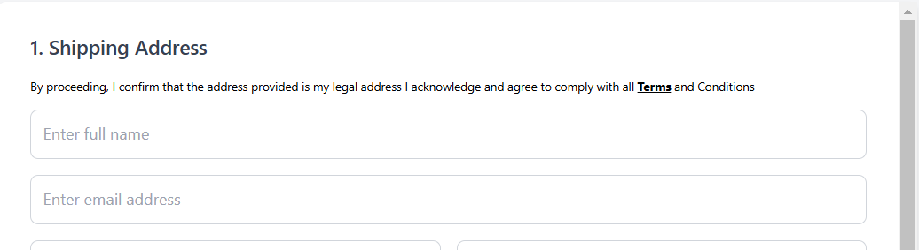

## Invoice Pdf Generator

Invoice

An invoice is a document that provides a detailed record of a transaction between a buyer and a seller. It includes information such as the products or services purchased, their quantities, prices, total amount due, and payment details. In e-commerce, an invoice serves as proof of purchase for both the customer and the seller, ensuring transparency in the transaction. It also helps track sales, manage finances, and resolve any potential disputes or returns in the future.

"After successfully completing all the steps, the user reaches the final stage of placing their order. To finalize, the user must click the 'Place Order' button on the shipping form.



Once the 'Place Order' button is clicked, an invoice is generated in PDF format. This process may take a few seconds, particularly the first time, typically around 5 to 6 seconds. After the PDF invoice is generated, it is automatically downloaded to the user's device. The PDF invoice contains detailed information about the order, including the items purchased, their quantities, prices, and the user's shipping and payment details."

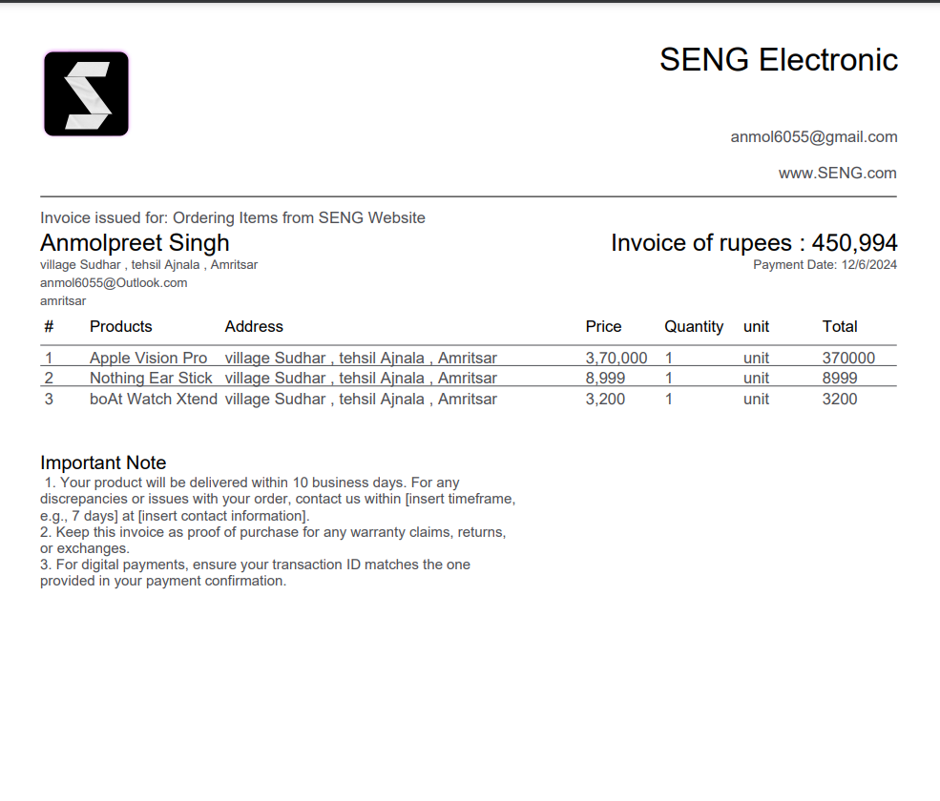

This is a live demonstration of how our invoice document appears

The invoice document begins with the company brand details at the top, which include the brand logo, the brand's name, email contact, and website URL. Below this, the invoice details are provided, such as the purpose for issuing the invoice and the customer information.

Customer information includes the customer’s name, address (as entered in the shipping form), email, and city.

On the right side of the document, the invoice details are displayed, including the total amount, payment date, and the date the invoice was generated.

Following this, a detailed list of the purchased products is shown, including the product names, quantities, and prices. This layout ensures that all necessary details for the customer and seller are clearly outlined for future reference.

Creation of PDF Generator Function or Mechanism

The PDF generation functionality in this project is implemented using the jsPDF open-source library.



JSPDF is a JavaScript library that allows you to generate PDF files directly from your web pages. It is a powerful tool for web developers to create and generate PDFs on the fly, making it ideal for businesses, schools, and other organizations that require a way to produce professional and polished PDFs quickly and easily.

Today, we will use jsPDF to download an HTML file as a PDF, images, colors & backgrounds

Question : Why We Choose PDF Over Any Other Format for the Invoice Document ?

Ans: PDF is chosen for generating the invoice document because it is a universally accepted format that ensures the content looks consistent across all devices. It is secure, easy to share, and supports features like non-editable text to maintain document integrity. Additionally, PDFs can include structured layouts, making them ideal for professional documents like invoices. This format guarantees that the user can easily download, view, and store their invoice without compatibility issues.

Once the PDF is successfully generated, the user will see an "OK" button on their screen. Clicking this button saves the user's session and redirects them back to the home page. The entire process is refreshed, providing the user with a seamless reset and an opportunity to start a new shopping experience if they wish to make another purchase.

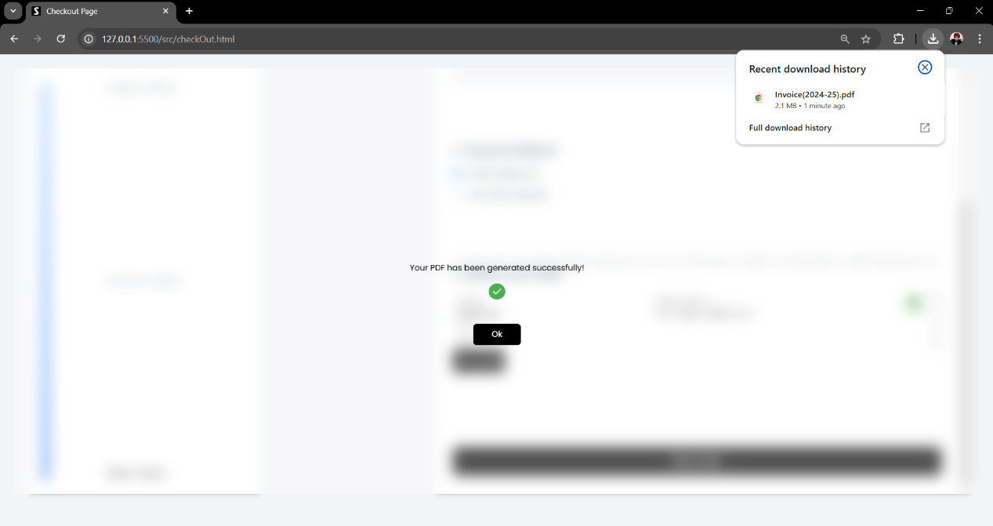

This is the demonstration of the final window with the "OK" button, displayed to the user after successfully completing the purchasing process. Below, you can see how the interface looks, providing a clear indication that the transaction is complete and allowing the user to reset and start a new shopping journey.

All the features discussed so far primarily focused on the functionalities and services provided to users within this website project. However, let us now delve into a critical feature that makes all these functionalities work seamlessly across various devices- Responsiveness.

## Responsiveness

What is Responsiveness and Why is it Important?

Responsiveness refers to a website's ability to adapt its layout, design, and functionality seamlessly across various devices and screen sizes, such as desktops, tablets, and smartphones. It ensures that users have an optimal viewing and interaction experience, regardless of the device they use.

In today's digital era, where users access websites from diverse devices, responsiveness is essential to maintain usability and accessibility. A responsive design improves user satisfaction, increases engagement, and enhances the website's overall performance. It also ensures compatibility across different platforms, making the website efficient and user-friendly.



In our project, responsiveness has been implemented using CSS media queries and features like min-width, max-width, height, and the powerful clamp() function for responsive typography. These techniques help adapt the layout, design, and text size to various screen sizes effortlessly.

Below is a demonstration showcasing the responsive UI design of our webpage, highlighting how it appears side by side on both desktop and mobile versions. This ensures that our users have a consistent and enjoyable experience, regardless of the device they use.

1. Welcome Page Responsiveness

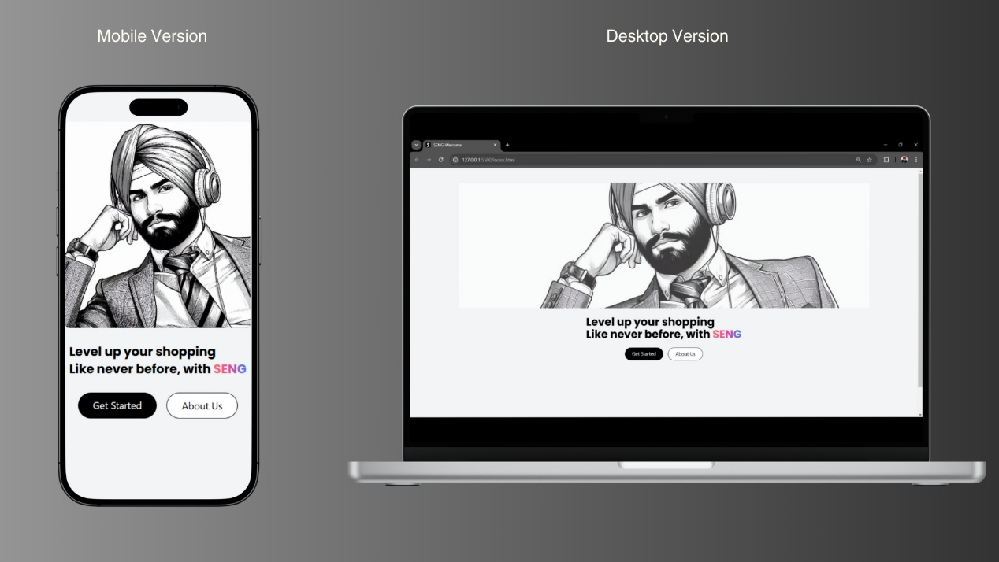

1. Home Page Responsiveness

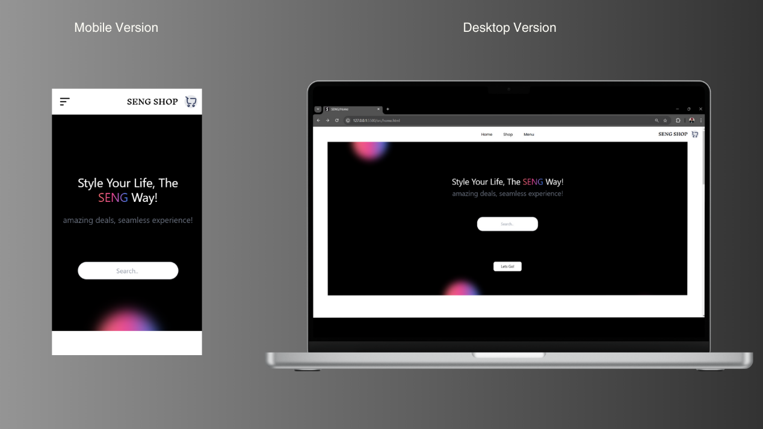

1. Product View Responsiveness

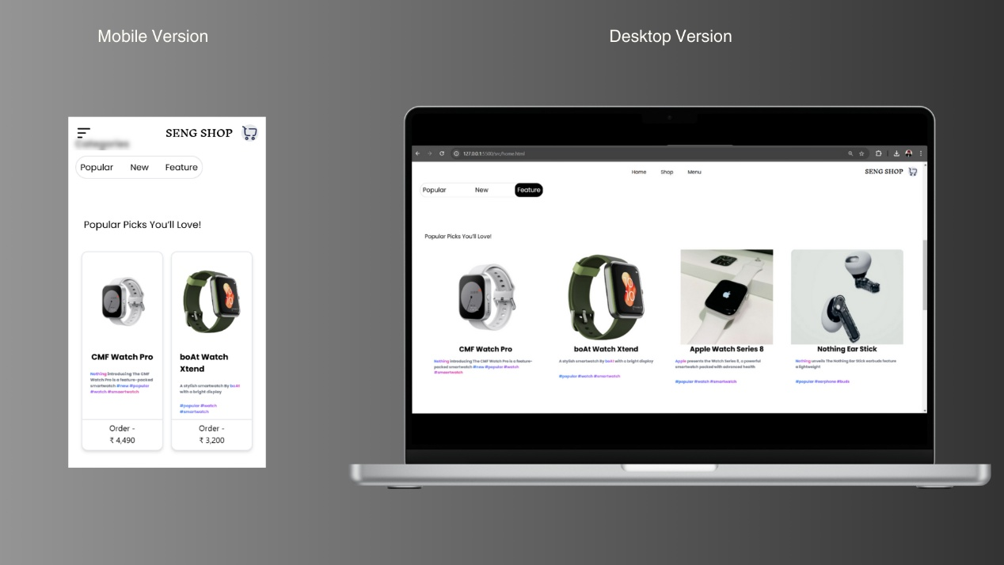

1. Product Cart Responsiveness

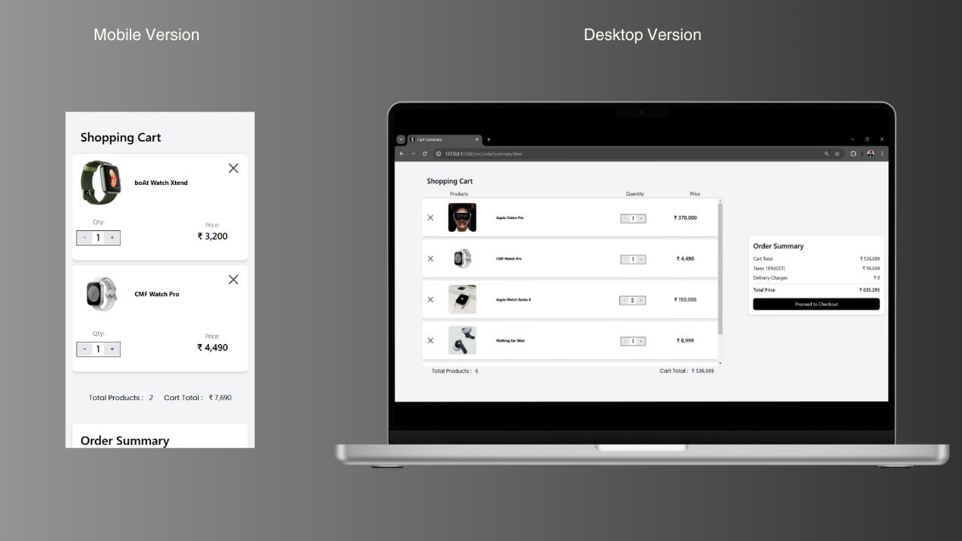

1. Checkout Process Responsiveness

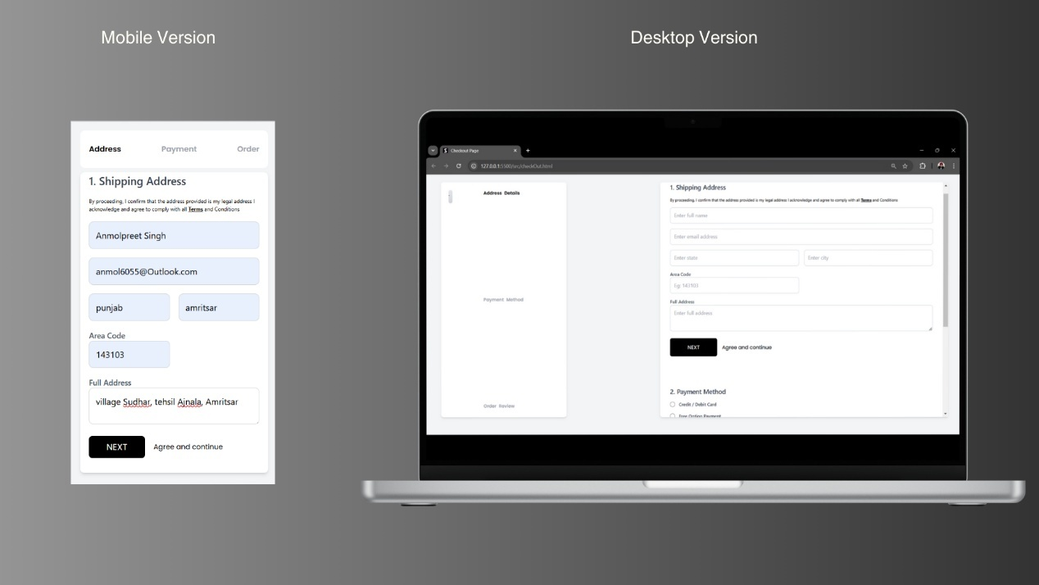

1. Menu Responsiveness

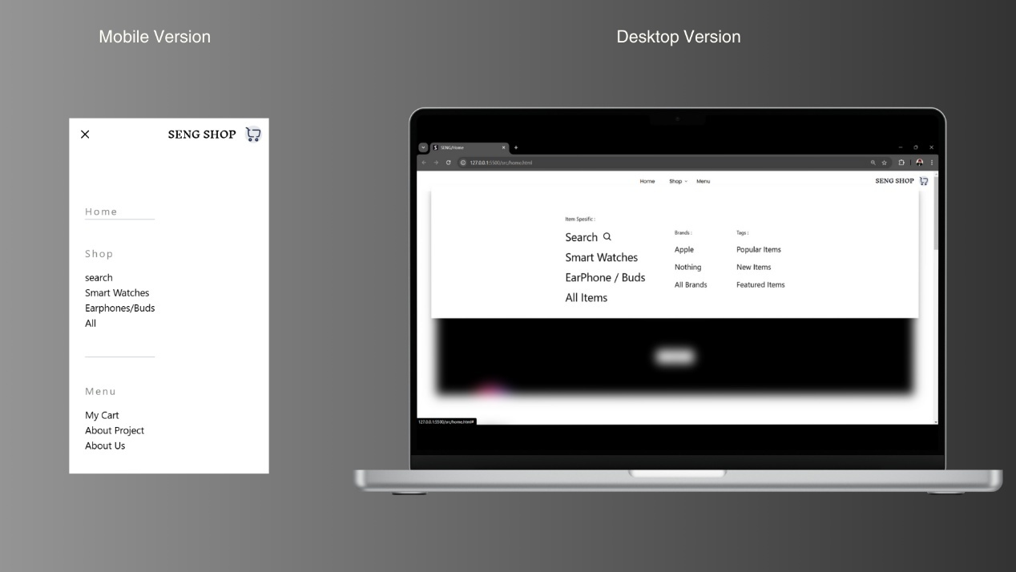

# Tailwind CSS

Tailwind CSS is a utility-first CSS framework that simplifies web development by providing a set of pre-designed utility classes. These utility classes enable you to build custom designs without writing any custom CSS, promoting consistency, scalability, and efficiency.

Tailwind shifts the focus from traditional CSS components to functional utility classes, empowering you to build responsive and visually appealing interfaces with ease and speed.



Below are demonstrations from our project where Tailwind CSS implementations are showcased. For most of the design and layout, we relied on the efficiency and utility-first approach of Tailwind CSS.

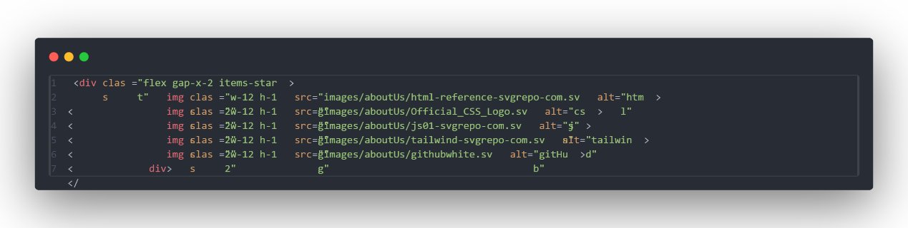

This example illustrates how we utilized Tailwind CSS utility classes to style the About Us page in our project, replacing traditional CSS for a more streamlined approach. Below is the output of this code:



This is the resulting output obtained after implementing the above source code.

Let's compare this example of Tailwind CSS code with its traditional CSS equivalent to see how much code has been reduced by using Tailwind. This comparison highlights the time and effort saved when using Tailwind CSS over traditional CSS.

To showcase the same output from both Tailwind CSS and traditional CSS, below are the demonstration codes for both

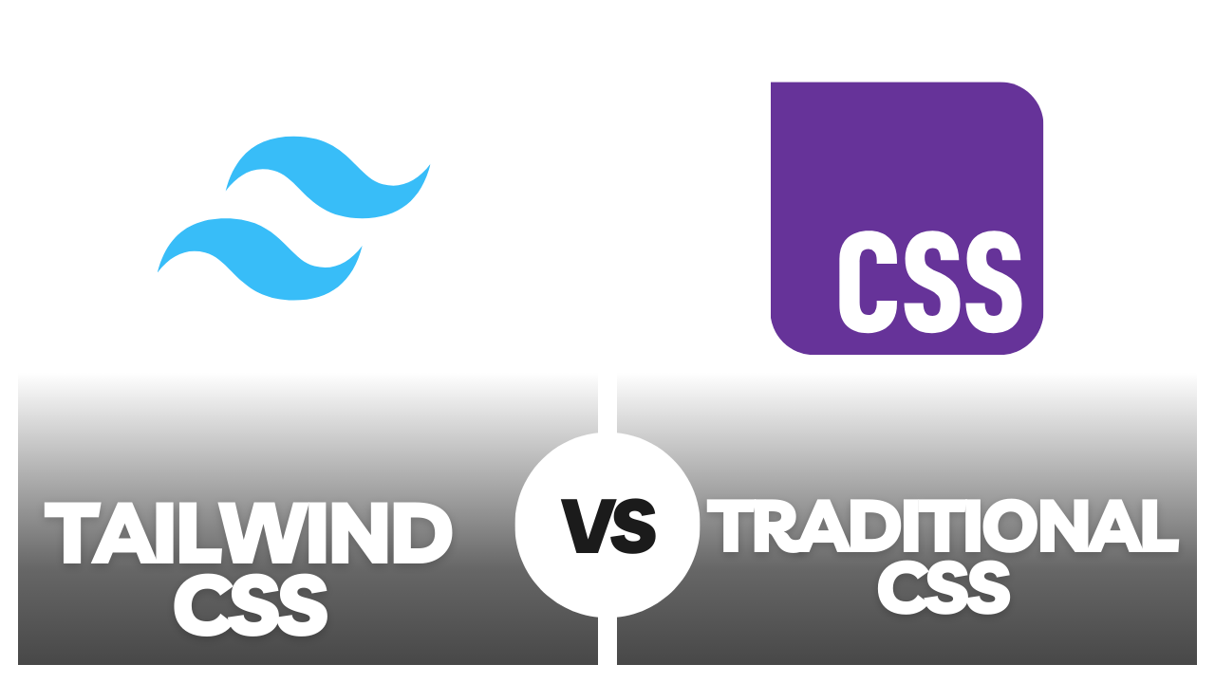



This is Tailwind CSS version

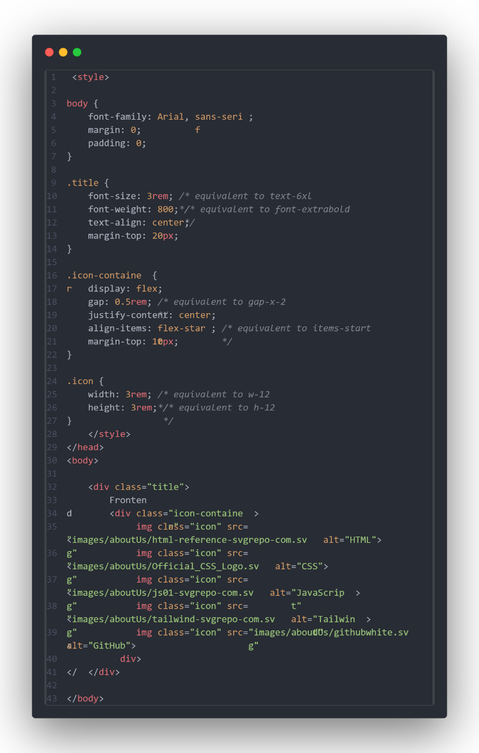

This is Traditional CSS version



This is the output we get after implementing the source code examples from both Tailwind CSS and traditional CSS. Both approaches will give us the same result.

This is why we use Tailwind CSS instead of traditional CSS. It saves us a lot of time and effort by reducing the amount of code. Less code means we can manage our project more efficiently. Since Tailwind is very flexible, it helps us design different websites quickly. Even if we use the same colors and sizes, we can easily create a completely new look for the next project

# GIT HUB

GitHub is a platform for version control and collaboration, allowing developers to store and manage their code in repositories. It is built on Git, a version control system that tracks changes to files, helping developers collaborate efficiently, revert to previous versions, and manage different versions of their codebase.



GitHub has played a crucial role in our project in several ways.

1. Source Code Management: We used GitHub remote repositories to manage our source code efficiently and securely store it online.
2. Change Tracking: GitHub helped us track all the changes made to our code throughout the development process, ensuring transparency and version control.
3. Project Publishing: By using GitHub Pages, we published our web project to showcase and test it on a live platform.
4. Project Sharing: GitHub made our project easily shareable by providing direct links to both the repositories and the live published version of the project.

Below is the demonstration of our GitHub repository for this project.  
Additionally, we have provided the repository link, which can be easily accessed through any browser.

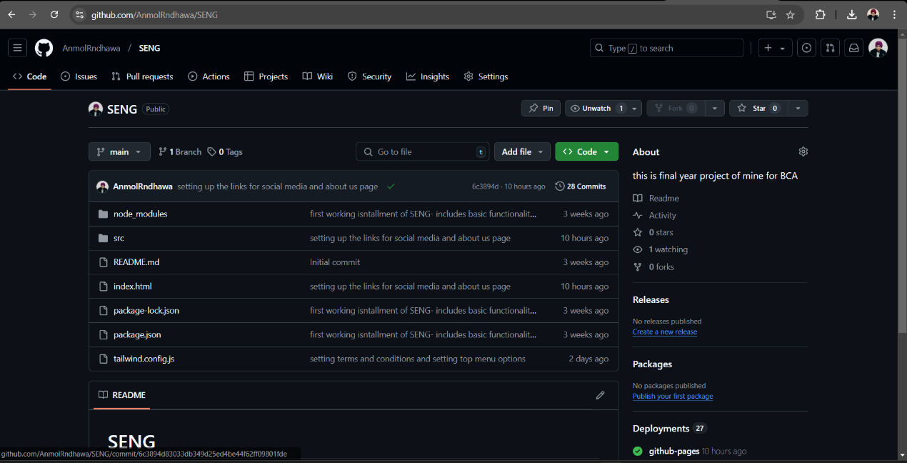

Git Hub Repository links:

<https://github.com/AnmolRndhawa/SENG.git>

<https://anmolrndhawa.github.io/SENG/>

# Future Updates and Possibilities

As we conclude this project report, let's discuss the potential updates and improvements we aim to achieve in the future:

1. Enhanced Security Features

Currently, the project uses JavaScript's local storage to save user data, which is not ideal for ensuring high levels of security.

In the future, we plan to implement advanced security measures to make the website more secure for both users and the business.

1. Advanced Product Filtering

Adding features like product filters will allow users to search for items more effectively by applying narrow conditions.

This will improve the user experience and make the website more user-friendly.

1. Order Tracking and Email Notifications

Features like order tracking and email confirmations for user orders are also on our priority list.

While we've begun planning for these, their implementation requires hosting on online platforms, as these features cannot function on local hosts.

1. Backend Development for Extended Features

To achieve the above goals, we need to acquire and apply skills in backend development, such as PHP, and integrate advanced functionalities.

These updates will make the website more comprehensive and efficient.

With continuous learning and efforts, we are determined to implement these future updates, much like the success of this current project.

# Links And References

Below are the links and references used throughout the project. These resources provide deeper insights into the topics covered and live demonstrations of the features implemented:

1. For Live Website Demo

<https://anmolrndhawa.github.io/SENG/> - GitHub URL



GitHub URL

1. For Source Code

<https://github.com/AnmolRndhawa/SENG.git> -Git Hub Repository

1. Other Links

<https://github.com/AnmolRndhawa> - Git Hub Profiles

<https://tailwindcss.com/> - Tailwind Css

1. Student Contacts

<https://x.com/AnmolRndhawa?t=I1P9KLbWyWiqqHNxT4zBlQ&s=09> -X platform / Tweeter

[anmol6055@Outlook.com](mailto:anmol6055@Outlook.com) – email contact

1. Project Report

This report has been created using Microsoft Word, adhering to all the guidelines provided by the university with utmost respect and care.

Thank you for taking the time to review my work.

Sincerely,  
Anmolpreet Singh